

**BSc (Hons) Computer Science and Software**

**Engineering**

UNIVERSITY OF BEDFORDSHIRE

HireBuddy : Online Automobile Service Platform

**Submitted by:**

**1727525**

**Nuwantha Fernando**

Abstract

There are thousands of vehicles moving around the planet daily with the intention of different tasks. But people are unable to do their day to day tasks because of many vehicle malfunctions like vehicle breakdowns and tire punctures. Even though there are several firms offer such services to repair vehicles they're ineffective to find the client and supply the service to them at the place of the cause. Therefore it can be terribly valuable if it's potential to try this, but sadly up to date there has been no state of affairs that has found an answer to the current situation. ”Hire Buddy: Online automobile Service Platform” is the best answer for everyone who face quite issues in their day to day life. Proposed system can be a replacement era of automobile repairing services as a result of this can be terribly fast, efficient and very low cost. Therefore the customers will be definitely satisfied with the proposed system. Through this system, the clients can easily request the service of the motor mechanic or tire technician related to their vehicle issue. Proposed Android device primarily based on reviews and skill of the service provider. So service providers will notify regarding the necessity of the customer. According to the required service and the location of the customer service team can attend the place as fast as possible. Also the projected system has a feature for the user to examine the time that takes for the service team to reach the given location. Our main approach is to build a user friendly application as well as a mobile application based on Android, to build a connection between the client, motor mechanic and tire technician.

Acknowledgement

I would like to express my special thanks of gratitude to my supervisor “Mr. Roshan Jayawardana” for his able guidance and support in completing my Project. I would also like to extend my appreciation to “Ms. Gayana Fernando” the lecturer accountable for Undergraduate Project for guiding me from selecting an appropriate research point until the last viva.

Secondly, I would also like to thank my parents’ colleagues who helped me a lot in finalizing this project within the limited time frame.

Special much gratitude goes to “Ms. Shahani Farwin”, who helped me and guided me to clarify the problems I confronted during developing the system.

Dedication

I finally dedicate my project to my family whose untiring support and assistance have made possible the fruition of my efforts. To my supervisor, Mr. Roshan Jayawardana and my lecturer in charge, Ms. Gayana Fernando.

Contents

|  |  |  |  |
| --- | --- | --- | --- |
| Abstract | .......................................................................................................................................................... | | i |
| Acknowledgement ........................................................................................................................................ | | | ii |
| Dedication .................................................................................................................................................... | | | iii |
| Chapter 01: Introduction .............................................................................................................................. | | | 1 |
| 1.1 | Project Background ....................................................................................................................... | | 1 |
| 1.2 | Aim and Objectives ....................................................................................................................... | | 2 |
| 1.3 | Project framework ........................................................................................................................ | | 3 |
| 1.4 | Structure of the report .................................................................................................................. | | 4 |
| Chapter 02: Literature Review ...................................................................................................................... | | | 6 |
| 2.1 | Introduction .................................................................................................................................. | | 6 |
| 2.2 | OCR technology applicable areas .................................................................................................. | | 6 |
| 2.3 | Text detection and recognition from an image ............................................................................ | | 8 |
| 2.4 | Design of OCR ................................................................................................................................ | | 9 |
| 2.5 | Text to speech ............................................................................................................................. | | 10 |
| 2.6 | Image filtering ............................................................................................................................. | | 11 |
| 2.7 | Symbol recognition in OCR base calculator ................................................................................ | | 12 |
| 2.8 | Similar applications ..................................................................................................................... | | 13 |
| 2.9 | Conclusion ................................................................................................................................... | | 16 |
| Chapter 03: Methodology ........................................................................................................................... | | | 17 |
| 3.1 | Introduction ................................................................................................................................ | | 17 |
| 3.2 | Planning of the system………………………………………………………………………………………………………….. | |  |
| 3.2 | Requirement gathering and analysis .......................................................................................... | | 18 |
| 3.3 | Design .......................................................................................................................................... | | 21 |
| 3.3.1 | | Project plan ......................................................................................................................... | 22 |
| 3.3.2 | | Gantt chart .......................................................................................................................... | 23 |
| 3.3.3 | | WBS chart ............................................................................................................................ | 25 |
| 3.3.4 | | Interfaces Design ................................................................................................................. | 27 |
| 3.3.5 | | System Design ..................................................................................................................... | 29 |
| 3.4 | Implementation .......................................................................................................................... | | 33 |
| 3.5 | Testing ......................................................................................................................................... | | 46 |
| 3.6 | Evaluation ................................................................................................................................... | | 62 |
| Chapter 04: Results and Discussions ........................................................................................................... | | | 65 |



Chapter 05: Conclusion 66

5.1 Benefits 66

5.2 Limitations 67

5.3 Summery 67

5.5 Feature works 68

References 68

Appendix A - Interview Questions 74

Appendix B - Evaluation form 75

Appendix C - Poster 77



v | P a g e

Table of figures

Figure 1: Visually impaired per million population 2

Figure 2: Text detection and recognition process 8

Figure 3: Feature extraction process in detail 9

Figure 4: Detailed view of text to speech process 11

Figure 5: Image filtering methodes 12

Figure 6: Detailed comparison with currently existing products 15

Figure 7: Usage of smart devices for their health care 16

Figure 8: Graphical view of Spiral model 18

Figure 9: Process of requirement gathering 19

Figure 10:Daily engaging tasks 20

Figure 11: Total number of people 20

Figure 12:opinions about the system 21

Figure 13: GANTT chart 01 24

Figure 14: GANTT chart 02 24

Figure 15: GANTT chart 03 25

Figure 16: Work Breakdown Structure for the proposed project 26

Figure 17: Splash screen 27

Figure 18: Main interface 28

Figure 19: Interface with floating buttons 29

Figure 20:Usecase Diagram 30

Figure 21: Activity Diagram 31

Figure 22: Flow Diagram 32

Figure 23: graphical view of android platform 34

Figure 24: Code segment for import image from gallery 35

Figure 25: Code segment for capture image from camera 36

Figure 26: Result handling 37

Figure 27: process image to increase the quality 38

Figure 28:Correct the image orientation 38

Figure 29: Text recognition process 39

Figure 30: Recognized text set in to text view 40

Figure 31: Web search function 41

Figure 32: Calculation process 44

Figure 33: Text to speech 45

Figure 34:Speech to text 45

Figure 35: Testing methods 46

Figure 36:Performences of the application 63

Figure 37: Comments given by the users 64

Figure 38: Interview questions 74

Figure 39: Evaluation form part 1 75

Figure 40: Evaluation form part 2 76

Figure 41: Poster 77



vi | P a g e

Chapter 01: Introduction

This part of the report incorporates an introduction about the Final Thesis Report that contains the background, objectives and aims, framework of the proposed system as well as the structure of the Final Thesis report.

1.1 Project Background

In past few years there has been a significant increment of world population. And then the vehicle population is also increased parallel with the world population of people. With the day to day tasks people used to drive carelessly and because of that the vehicle accidents, vehicle breakdowns as well as tire punches are increased. This reality may squander the significant time of the general population and therefore they neglect to oversee and to complete their day to day activities on time. Along these lines, People need a decent answer for this issue. Most insurance agencies offer few arrangements, however those are not much practical. This project expects to build up a portable application dependent on Android that guides people to get the help of a proper person around the area to repair the vehicle's disappointment.

Breakdown cover service is a helpful strategy for roadside fixes if the vehicle failures while people are out on the town. This implies a prepared specialist will come to fix the vehicle. Having the correct breakdown spread can get the general population out of inconvenience and spare the cash. This kind of service could be the best alternative if people drive far, or if people just drive once in a while. If people are on a problem of spending more, the mechanic will give them a reasonable cost and these sorts of spreads are valuable if people are facing many difficulties with their unreliable vehicle that might not start, or if they are far away from a garage.

"Hire buddy" isn't only for help from a professional but also it offers a lot of features to the client such as accessing to the insurance portal directly as well as offering a cost calculator. By utilizing "Hire buddy" the client ready to get free calls with the specialist, just as it gives a cost adding machine and access to the protection entrance specifically. Future more, the application will give information to the nearest police stations, nearest hospitals as well as the nearest insurance agencies. Moreover, the proposed framework will be beneficial for every single person to expand their efficiency while diminish the outstanding task at hand.

1.2 Aim and Objectives

**Aim**

The purpose of this proposed framework is to build up an android based mobile application which guides the client to get the help of the appropriate person nearby to fix the vehicle disappointment.

**Objectives**

* To find existing comparative virtual products and distinguish the short comes of them, which can incorporate as an exceptional element of the framework.
* To distinguish dangers which happened when the implementing the application
* To plan and execute a calculation to calculate the expense of the required customer service.
* To build up a product which will regularly use by the client.
* To assess the advancement of the proposed framework by executing a trial.

1.3 Project framework

First of all, to confirm that the proposed framework is attainable, look into papers, surveys and articles were evaluated just as case studies was finished. With the assistance of these articles, information of the foundation of the proposed framework and learning about the current mechanical circumstance was picked up.



I made a questionnaire to assemble primary information and distributed it on social gatherings. To gather secondary information articles have been audited and required programming was chosen. There after by utilizing this examined information it chooses the unique features for the framework and also the other suitable features were chosen. At last the Methodology or the life cycle model chose by accomplish the final item of course and to convey a helpful framework with regards to the gathered primary information.

Work Breakdown Structure was build to get clear thought of the proposed framework, and use case chart was controlled to distinguish the inside foundation of the framework. The Gantt chart was build to take the proposed system in the timeline

Proposed framework will create utilizing Android Studio and Agile Methodology chosen as the life cycle demonstrates. With regards to the Agile Methodology the proposed framework will deliver sprint wise.

1.4 Structure of the report

In this, The Final Thesis report of “HireBuddy” android based mobile application will consist of 5 main chapters as mentioned below.

1. Introduction
2. Literature Review
3. Methodology
4. Results and Discussion
5. Conclusion

**Chapter 1: Introduction**

This is the main chapter of this Final Thesis Report which explains the overall context of the project background, the reason for choosing such a matter as the subject and the outcomes of the proposed framework. The introduction on Aims and Objectives gives an idea of the proposed framework that finally going to accomplished. And furthermore Project Framework is giving brief depiction about how phases of software development life cycle are including with the proposed framework.

**Chapter 2: Literature Review**

The second chapter of the report is “Literature Review”. This can be consider as the most valuable chapter of the report. It provides detailed explanation about the researched areas which investigate to complete this proposed system successfully. And also this chapter gives a detail comparison between similar existing products and the “HireBuddy” application to prove its uniqueness and the accuracy.



**Chapter 3: Methodology**

This section will disclose the methodology picked to build up the framework, gathering and analyzing of primary and secondary data, the arrangement of the project with significant outlines and charts, pertinent framework graphs and the underlying plan of the framework as well as the implementation details and code segments.

**Chapter 4: Testing and Results.**

Test cases and the results of them are included in this chapter. The screenshots of the obtained results during the testing also included as required evidences.

**Chapter 5: Evaluation**

This section will incorporate how the evaluation as well as the critical discussion based on the evaluation of the framework is done.

**Chapter 6: Conclusion**

As the final chapter of this report it gives an overall idea about the proposed system and the importance as well as the benifits of it. Basically this chapter includes an explanation about the limitations and the developments that can be added to the system in the future.



Chapter 02: Literature Review

This section includes the reviewed literature and the applicable extraction for this exploration, from the current available literature connected with “Hire Buddy: Online Automobile Service Platform”. The section is additionally subdivided dependent on the title of the each research paper.

2.1 Introduction

This chapter mainly focuses to identify and discusses the gravity of the topic OCR (Optical Character Recognition) technology as well as currently developed and researched areas about the OCR field. By exploring articles, academic journals, books and research papers identified new features which can add to this project. Identified new features, modern technologies and proper comparison between this application and the applications currently available in the market which have been more beneficial to increase the accuracy and the uniqueness of this project. By investigating different research papers and relevant articles helped to identify pros and cons of the OCR topic as well as possible challenges of this area. The importance of this chapter is to analytically evaluate the different strategies used in OCR field. With the facts, detected a suitable platform for examining the questionnaires and way to improve the uniqueness of the project.

2.2 OCR technology applicable areas

OCR (Optical Character Recognition) is a component which reading texts from graphical image with a software. With the use of this technology people are able to free from manual data entering. Text recognition system extracts texts from documents and insert in to database

. Verma et.al (2016) clearly stated that presently this technology widely being used in many industries and following overview described some application areas of OCR.



6 | P a g e

**Banking**

OCR technology widely used in banking industry for cheque clearing without human involvement. By inserting cheque in to the machine, all features are scanned through the OCR and after successfully completion of scanning of the cheque that will be accepted. It is rarely required manual confirmation. This process more suitable for printed cheques and fairly effective in handwritten cheques as well. Overall, the result is efficient and reducing waiting times of the customer.

**Legal**

In legal industry, they are dealing with lots of paper based work. It will reduce space in the room. In order to free up space, they scan documents through OCR system and save them in computer database. So it is easy to search files in a computer rather than search it manually file by file in a filing cabinet.

**Healthcare**

In healthcare sector, it is possible to develop an application to scan images and extract the texts from the image. So, user is able to use that particular texts in any field as required. Basically this is more suitable for peoples with eyesight issues and others can efficient their tasks through OCR applications. And also this process can use in their paper works also. Normally Healthcare professionals deal with large volume of documents of patients. So with the use of OCR technology it is easy to create a digital database of documents and it is effective than a manual system.



7 | P a g e

2.3 Text detection and recognition from an image

The hidden concept of the OCR (Optical character Recognition) text detection and recognition from a graphical image is transforming the verbatim content in to ASCII value. The converted ASCII value can be used in various ways. According to the survey results conducted by Ye and Doermann (2015) have been stated that to recognize a text from an image, particular image must be converted in to string format. Such texts defined as” Structured edges”, “a sequence of identical color regions”, “a kind of texture” or “a collection of strokes”.

As per reference, Rizdania and Utaminingrum (2017) clearly described prior to the detection procedure of the content in the graphical image, particular image must be filtered through image processing mechanism. The inserting image must be transformed into 256 pixels for the shortest width or length, so the lengthier will have the reconciliation. This procedure is important and vital, so the application isn't overwhelming because of the large image sizes. Furthermore, Chandarana and Kapadia (2014) stated that OCR implemented through Matlab archived 92% of recognition rate and that rate higher than the recognition rate of ordinary OCR.

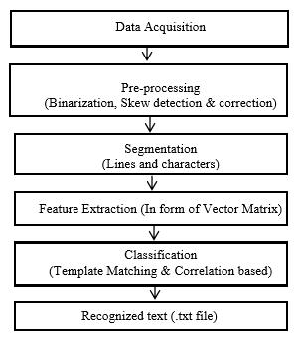

*Figure 2: Text detection and recognition process*



8 | P a g e

2.4 Design of OCR

There are different types of techniques available for design Optical Character Recognition system. Du et.al (2013) clearly stated that different types of techniques which are used to design OCR as below;

**Matrix matching:** Mostly known as pattern matching technique. Basically this approachtransform each and every character into a pattern which is locate inside a matrix. Afterwards it starts to compare the pattern with an index of identified characters. The accuracy and the recognition rate is high in mono typed and uniform single column pages.

**Fuzzy Logic:** This logic is multi-valued and enable transitional values to be characterized betweenconservative assessments like yes/no, true/false and so on. An attempts are more similar to the rational of a human than programming in PC. Fuzzy logic mostly applied when there is no distinct true or false value for the answers.

**Feature Extraction:** This strategy characterizes each character by the existence or inexistence ofmain features, including lines, width, density, height, loops, stems and other character qualities. Feature extraction is an ideal approach for laser print, OCR of magazines and excellent pictures.

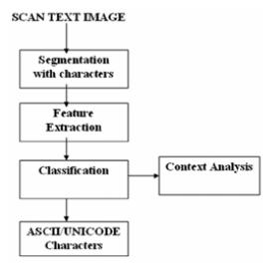

*Figure 3: Feature extraction process in detail*



9 | P a g e

**Structural analysis:** This approach identifies the character base on the sub features of an imagesuch as horizontal histograms, sub-vertical and shape of the graphical image. With that fact its’ character reparation ability perfect for low quality images.

**Neural Networks:** This system works more similar to human neural system. Once it received thepixels from image it will compare them with a known index of character pixel pattern. Therefore, this method more suitable for recognized text in damaged images.

2.5 Text to speech

With the help of OCR techniques, it is possible to detect the text from an image and after that recognized text translate into voice (speech). Aric et.al (2017) evidently expressed that Text to Speech could be a helpful component in various applications related to visually impaired and speech-enabled devices. Therefore, it helps peoples by reducing usage of visual interfaces.

Taylor (2009, p.77) observed that the Text to voice design contains set of modules related each other’s and the system has to continue the passing process one module to next module until the process complete. And also he explained that the ordinary systems use strings for the TTS design.

Translating text into a spoken wave form is the main task of the Text to voice system. Set of steps has to be complete to fulfill the task. Text Analysis, normalization form of the text, text processing, acoustic process and finally generating the speech. As the commencing stage of the process, text analysis is responsible for text sorting and arrange them into manageable list of words. After that sorted list of words filter through normalization and during this process all words are translate in to pronounceable form. This stage responsible for maintaining quality of the words, detect punctuation marks and pauses between words. Once the completion of



10 | P a g e

normalization, text prepared to process and it converts all the texts in to sequence of synthesis parts. Afterwards adding voices in to the texts through the acoustic processing stage. Finally, successfully completion of above stages, an acoustic waveform generates by speech generation and as the result words are out as speech.

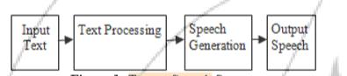

*Figure 4: Detailed view of text to speech process*

2.6 Image filtering

Zhang et.al (2012) has declared that the foggy, misty or hazy climatic conditions decrease the standard of a picture by reducing resolution and contrast of it. In order to make haze free image, this article proposing to enhance visibility of an image by use of novel effective algorithm. It clearly mentions that recognition rate of gray image or single color image higher than other types of images. In order to redraw fogless image, calculating the coefficient of normalized transmission with the dim channel previous. By the researched results, proved that proposed algorithm more easy and an effective method to enhance resolution and contrast of the misty image.



11 | P a g e

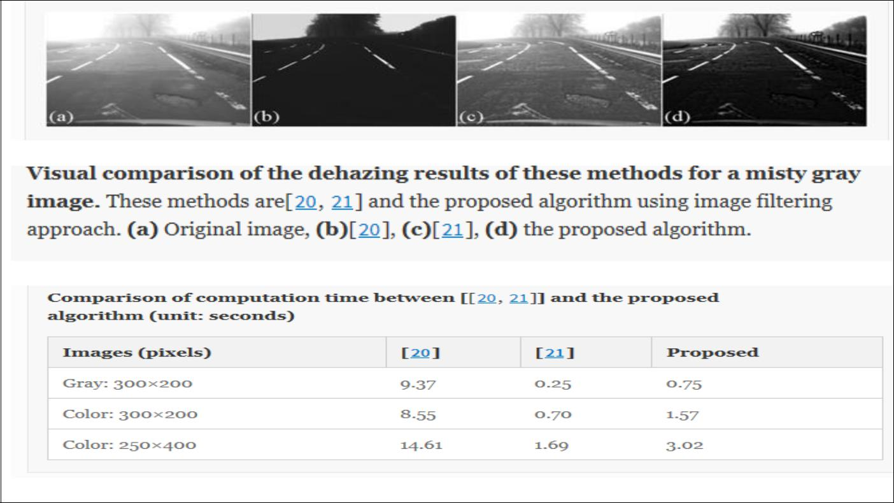

*Figure 5: Image filtering methodes*

2.7 Symbol recognition in OCR base calculator

Pranato et.al (2016) clearly stated that the structural analysis and the Symbol recognition are the two main steps in mathematical equation recognition. And also symbol recognition was identified as base of the structural analysis. Basically symbol recognition divide into two parts call segmentation and recognition. The inputs of the OCR (Optical Character Recognition) identified as set of strokes. Therefore, a mathematical symbol might contain multiple strokes. So the segmentation part responsible for the transforming strokes into a set of symbols and after particular symbol identified by symbol recognition stage. Basically neural network using for recognize symbol and to parse mathematical equation explicit syntactic use in structural analysis stage.



12 | P a g e

2.8 Similar applications

**Photomath**

Photomath is a OCR based android application which allows user to solve mathematical equations. It provides step by step instructions in a graphical way to solve the equation. Basically it helps user to understand the problem and teach to simplify similar type problems. Hamadneh and Al-Masaeed(2015) expressed that the application aims to solve mathematical equations through the mobile camera.

* Features
  + Able to detect hand written equations
  + Provide animated instructions
  + Simplify equations through the camera
* Limitations
  + Effective only with limited number of equation types.

**Photo calculator**

This application also developed to simplify mathematical equations through the mobile camera. OCR is the technology which is used to develop this application. For the user convenience it allows user to edit the detected equation if there is any difference with the actual equation.

* Features
  + Improved OCR system
  + Simplify equations through the camera



13 | P a g e

* Limitations
  + For some cases there is nothing to display after the scan.

**Text Scanner**

Text Scanner is OCR base application and it allows user to convert the graphical image into a text. It has inbuilt high speed reading methods and compatible with more than 50 languages all around the world.

* Features
  + Detect and recognize handwriting texts
* Limitations
  + Output fonts are very small and difficult to read.
  + Without the internet connection it doesn’t work.

**Text Fairy**

Text Fairy is an OCR base application which follows advanced image processing methods to detect text from the digital image. It allows user to edit the output and user can beneficial with text to speech function.

* Features
  + Detect and recognize handwriting texts
  + Compatible with more than 50 languages
  + Provide text to speech function.
* Limitations
  + Languages should be downloaded.



14 | P a g e

|  |  |  |  |  |  |  |  |  |  |
| --- | --- | --- | --- | --- | --- | --- | --- | --- | --- |
|  |  | Photomath | Photo | Text Scanner | Text Fairy |  | Scan | & |  |
|  |  |  | Calculator |  |  |  | Math(Proposed | |  |
|  |  |  |  |  |  |  | System) |  |  |
|  |  |  |  |  |  |  |  |  |  |
| Recognize the text | | **√** | **√** | **√** | **√** |  | **√** |  |  |
| from an Image |  |  |  |  |
|  |  |  |  |  |  |  |  |  |
|  |  |  |  |  |  |  |  |  |  |
| Text to voice |  | **-** | **-** | **-** | **√** |  | **√** |  |  |
|  |  |  |  |  |
|  |  |  |  |  |  |  |  |  |  |
| Simplify |  | **√** | **√** | **-** | **-** |  | **√** |  |  |
| mathematical |  |  |  |  |
|  |  |  |  |  |  |  |  |  |
| Calculations |  |  |  |  |  |  |  |  |  |
|  |  |  |  |  |  |  |  |  |  |
| Enlargeable | text | **-** | **-** | **-** | **√** |  | **√** |  |  |
| Output |  |  |  |  |
|  |  |  |  |  |  |  |  |  |
|  |  |  |  |  |  |  |  |  |  |
| Search on Web |  | **-** | **-** | **-** | **-** |  | **√** |  |  |
|  |  |  |  |  |
|  |  |  |  |  |  |  |  |  |  |
| Allow to edit | the | **√** | **√** | **√** | **-** |  | **√** |  |  |
| output |  |  |  |  |
|  |  |  |  |  |  |  |  |  |
|  |  |  |  |  |  |  |  |  |  |
| Voice Input |  | **-** | **-** | **-** | **-** |  | **√** |  |  |
|  |  |  |  |  |
|  |  |  |  |  |  |  |  |  |  |

*Figure 6: Detailed comparison with currently existing products*

Above figure 6 comparing the functionalities between currently available systems and the proposed system (Scan&Math). With this examination it will give a detailed explanation regarding distinctive functionalities of existing systems and proposed system while highlighting the exclusive functionalities offered by the proposed system.



15 | P a g e

2.9 Conclusion

In conclusion with the proofs delivered, utilizing Scan&Math offers useful and productive results to the user. It benefits users in various ways in their day today tasks. This review has described some OCR (Optical Character Recognition) techniques related to this project. Different types of applications related to this project and techniques have been carefully researched and studied to develop this application effectively. Most of existing applications are inefficiency because of utilizing old libraries and algorithms to their products. But with this application, it has been applied latest Google API libraries to increase performance and effectiveness of the application. As well as this product provides package of unique features like OCR web search and voice output in mathematical calculations for the users’ convenience. Likewise, this application offering attractive unique features to user as benefits. In addition, this application will upgrade to detect and recognize handwritten texts as future developments and adding surface view to capture customize area from camera. By adding these features in futures will be more beneficial to the users in their day-to-day tasks.

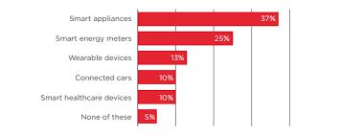

*Figure 7: Usage of smart devices for their health care*



16 | P a g e

Chapter 03: Methodology

3.1 Introduction

There are several kinds of methodologies that can be used for the development of mobile application. But there are strengths and weaknesses in all the methodology types.

So Agile Methodology was used for the proposed Online Automobile Application based on Android. Agile Methodology is highly recommended and known as a “gold standard” methodology in the market as it follows an iterative approach.

The purposes of choosing the Agile Methodology is by separating Implementation of the proposed framework in to sprints is going to help being developed and furthermore it is not normal for customary application advancement models, in here does not test the application at the final improvement stage. The Agile Methodology approach likewise gives the designer to modify the advancement procedure. There's no a specific method to make an application. It permits creating and launching the mobile application in different ways.

The below figure will help to identify how the agile Methodology works.

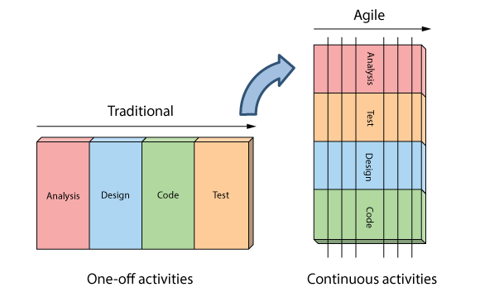

*Figure 21: Agile Comparison Chart*

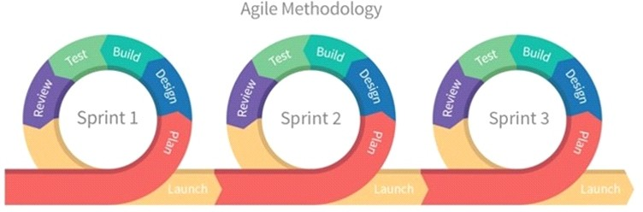

*Figure 22: Agile Methodology*

.

We can divide a project into “sprints” (Sub Parts) by using Agile Methodology. Sprint developments are done on iteratively as well as there is a deadline for each project.

As soon as a sprint completed, developer must have a testable potential product. It means Agile helps to create the project easier as well as it creates a product which suits to developers needs while minimizing complexity. The sprint duration is always fixed. That guarantees developers can regularly review the project's direction and keep it on track.

Below table gives an idea about the advantages and the disadvantages of the Agile Methodology.

|  |  |
| --- | --- |
| Advantages | Disadvantages |
| Faster turnaround times.  Able to detect and fix issues and defects faster.  There is a large community of agile practitioners whom are ready to share knowledge.  Don't have to worry about premature optimization.  Able to experiment and test ideas because it costs are low.  Deploy software quicker. | Hard to measure the progress.  Project can be ever-lasting because there’s no clear end.  Features that are too much to ﬁt into one or even several sprints are avoided because they don’t ﬁt into the philosophy.  Need to long term vision for the product and actively work on it.  Hard to measure the actual cost of the project. |

Planning of the system

Current plan and progress

For do the arranging of the proposed Hirebuddy framework Work Breakdown Structure was designed. WBS can be considering as a main component which helps to manage and organize the project work. WBS makes the project understandable and by breaking large tasks into small partitions it helps to manage WBS is not restricted as well as it can be able to use for any type of project.

Time management is also an important thing. In the purpose of making the achievements a success, time was planned perfectly. The Gantt chart was designed to plan the time. It will lead, through the whole venture to be done flawlessly. Gantt chart is following the Agile methodology. According to Agile Methodology, all kind of project related woks will be arranges as well as planned successfully.

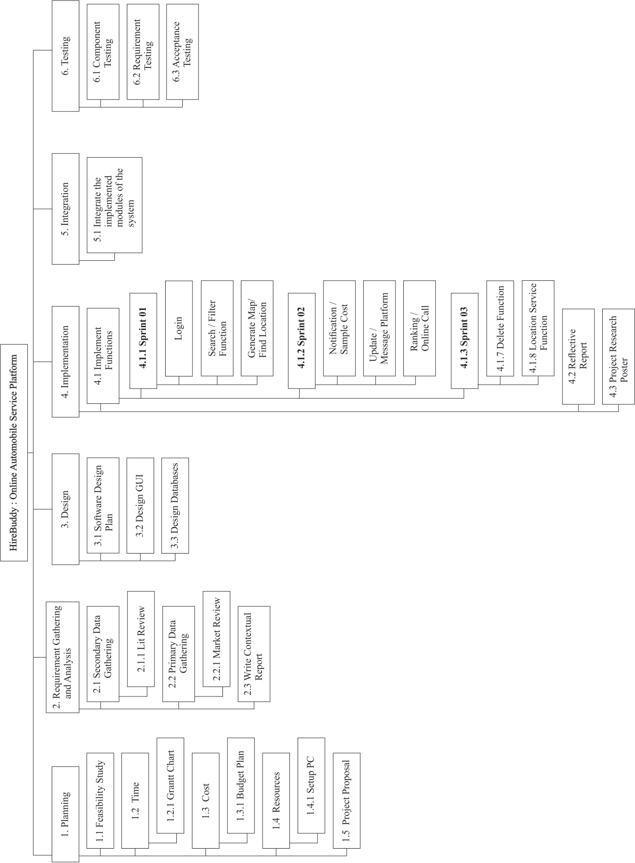

*Figure 20: Work Breakdown Chart*

3.2 Requirement gathering and analysis

Requirements gathered as primary and secondary data. Primary data collected by creating a questionnaire using “Google forms”. It was shared in social media groups to collect data. Shared questionnaire included with some questions which supports for the development.

The questionnaire which provided to analyze answers was shown in below.

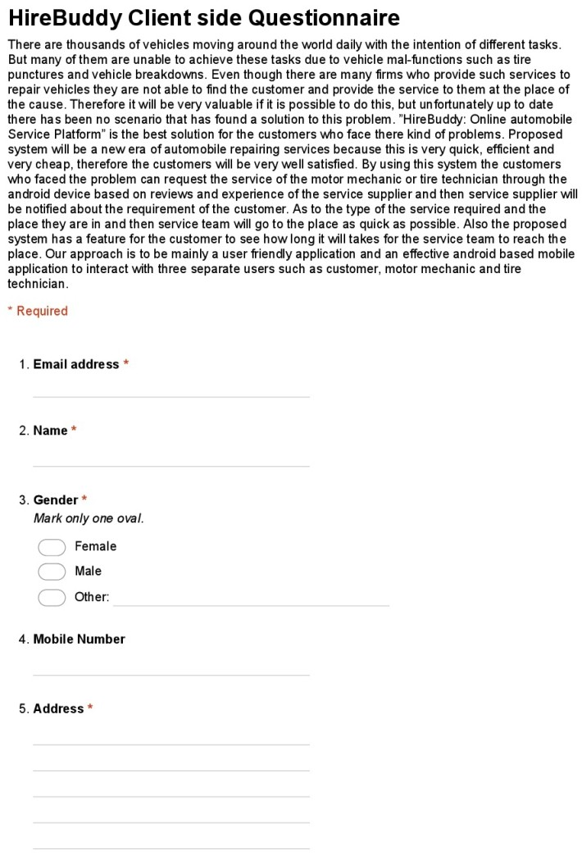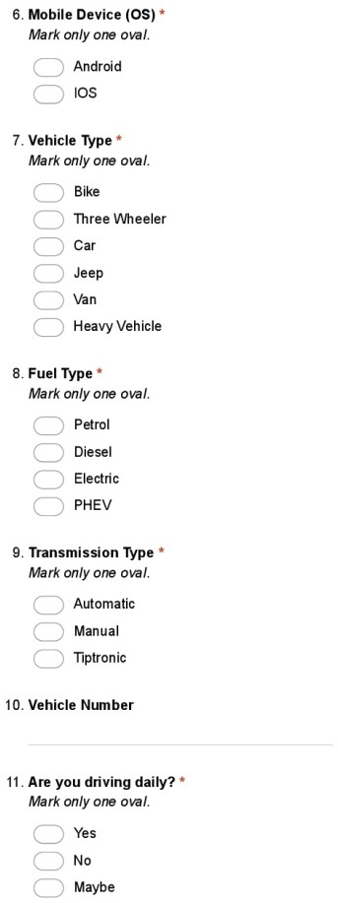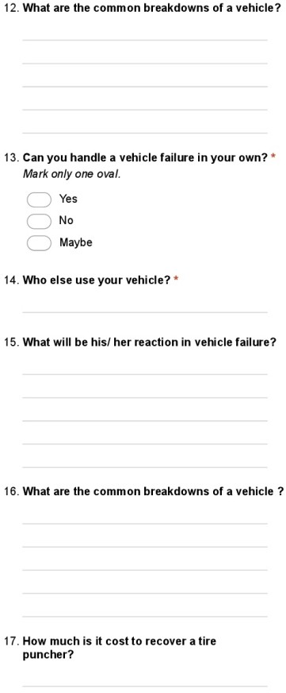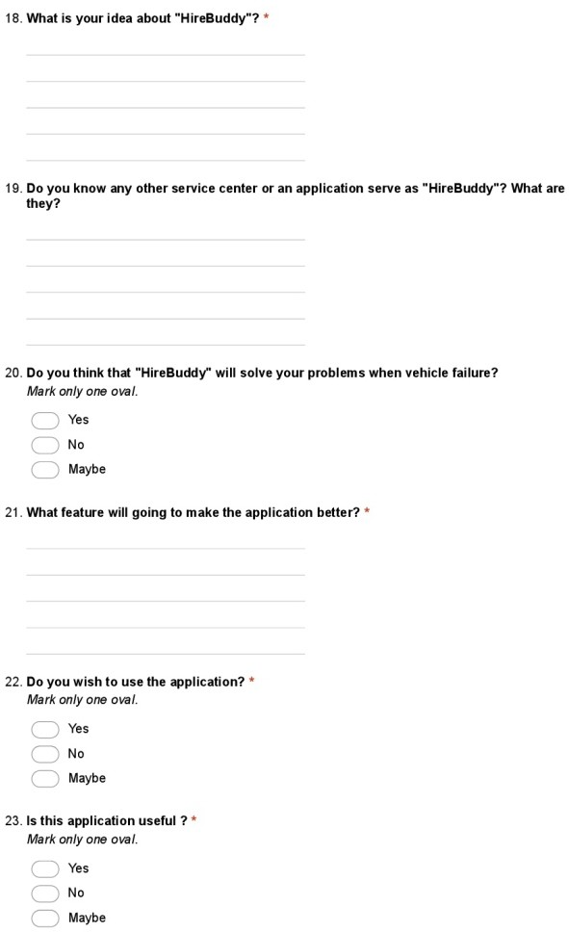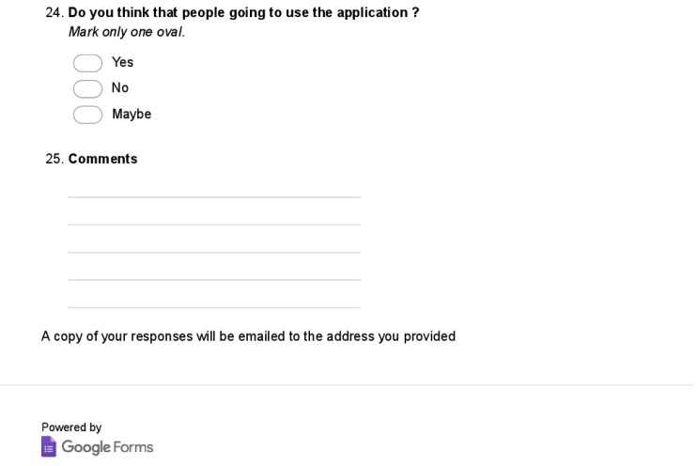

*Figure 23:Questionnaire*

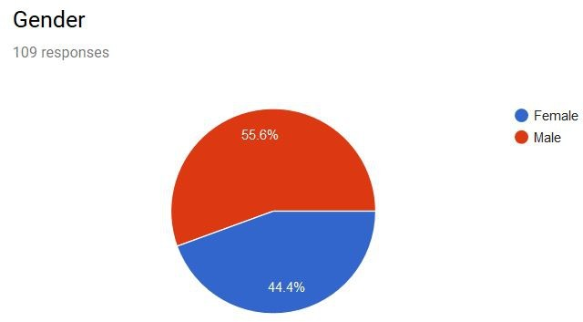

*Figure 24:Question part 01*

This figure shows the percentage of the vehicle usage of males and females. So as indicated by the above examined information it demonstrates that vehicles are generally utilized by males. As well as the use of vehicles of females additionally achieves about portion of the graph.

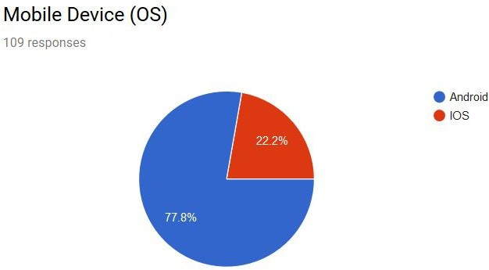*Figure 25:Question part 02*

As the ﬁgure appears over, most of the general population use Android based cell phones. Not many use ISO based mobiles.

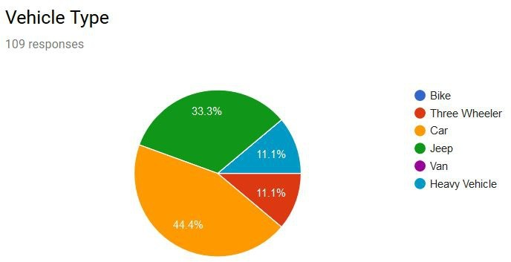

*Figure 26:Question part 03*

The above figure which demonstrates the vehicle types shows "Car" as the most trade-in vehicle type. The second spot taken by Jeeps while the third spot take by "Three Wheelers" and "Heavy vehicles" similarly.

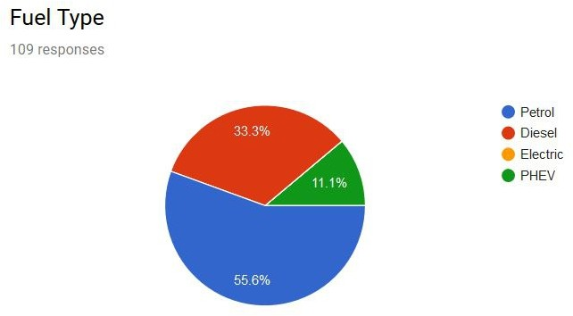

*Figure 27:Question part 04*

Petrol is generally the most utilized fuel type as per the above diagram. Furthermore the second place goes to diesel and then PHEV and Electric vehicles are less.

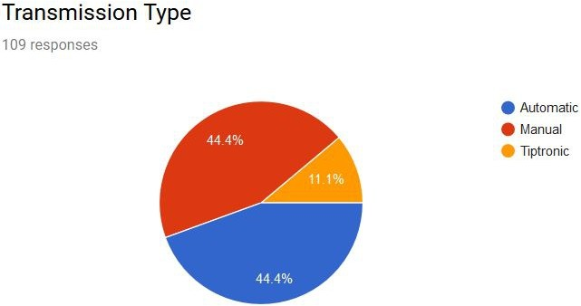

*Figure 28:Question part 05*

As indicated by the above broke down information Automatic and Manual Transmission types happen as greater part. Not many have the Tiptronic innovation.

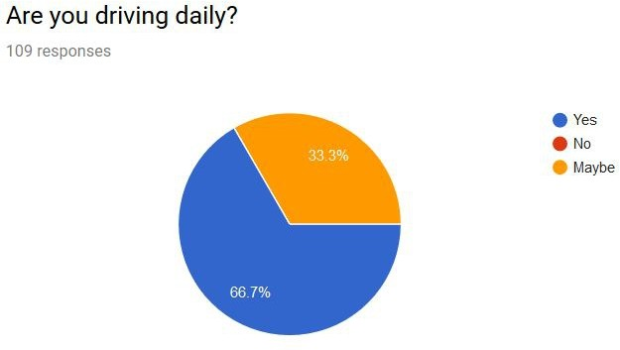

*Figure 29:Question part 06*

The majority are driving day by day as indicated by the above diagram. It’s hard to find a person who is not driving daily.

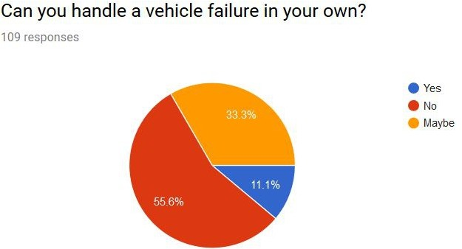

*Figure 30: Question part 07*

As the above figure demonstrates the majority of the general population can't deal with a vehicle disappointment in their own. No one but few can deal with a little yet most need the assistance of a technician.

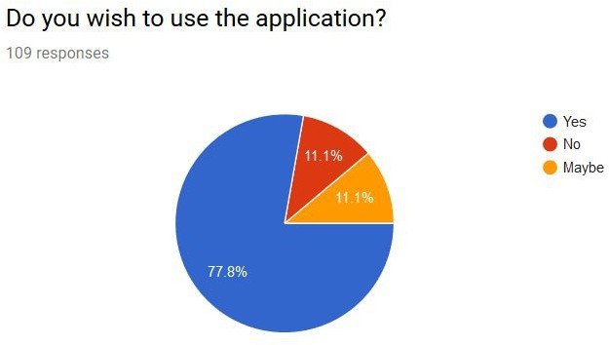

*Figure 31:Question part 08*

As indicated by the figure a large portion of the general population wish to utilize this application According to the dissected information.

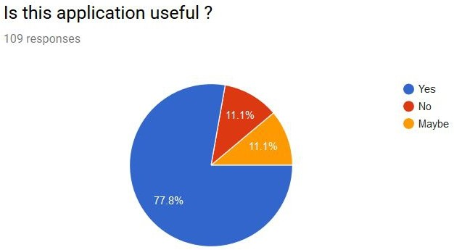

*Figure 32:Question part 09*

As the above chart it demonstrates that a great many people figure the application will be helpful for everybody in their everyday life.

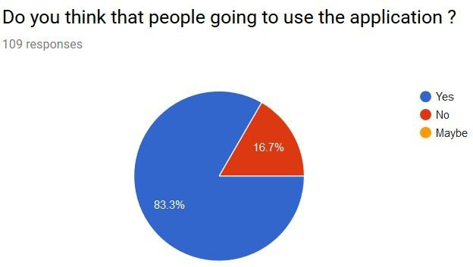

*Figure 33: Question part 10*

As indicated by the broke down diagram the larger part said "yes" to this inquiry. It implies a large portion of the general population believe that everybody will utilize this later on just as it will be extremely helpful.

3.3 Design

This section is the most important part of developing. Framework was planned so as to satisfy the necessities. This undertaking was done in 3 sub stages such as

* System Design
* Interface Design
* Database Design

3.3.1. System Design

First of all, the use case diagram designed to describe the functions of the system. It helps to specify a desired behavior of the proposed system and identify communication between system and the external entities.

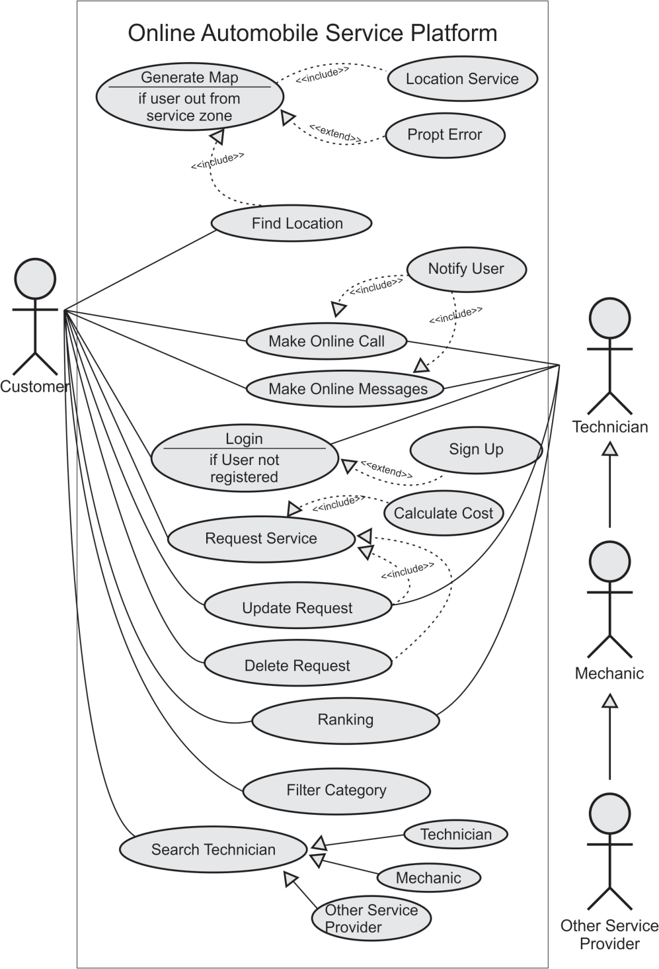

*Figure 34:Use Case Diagram*

High-level architecture diagram gives a general thought of the framework.

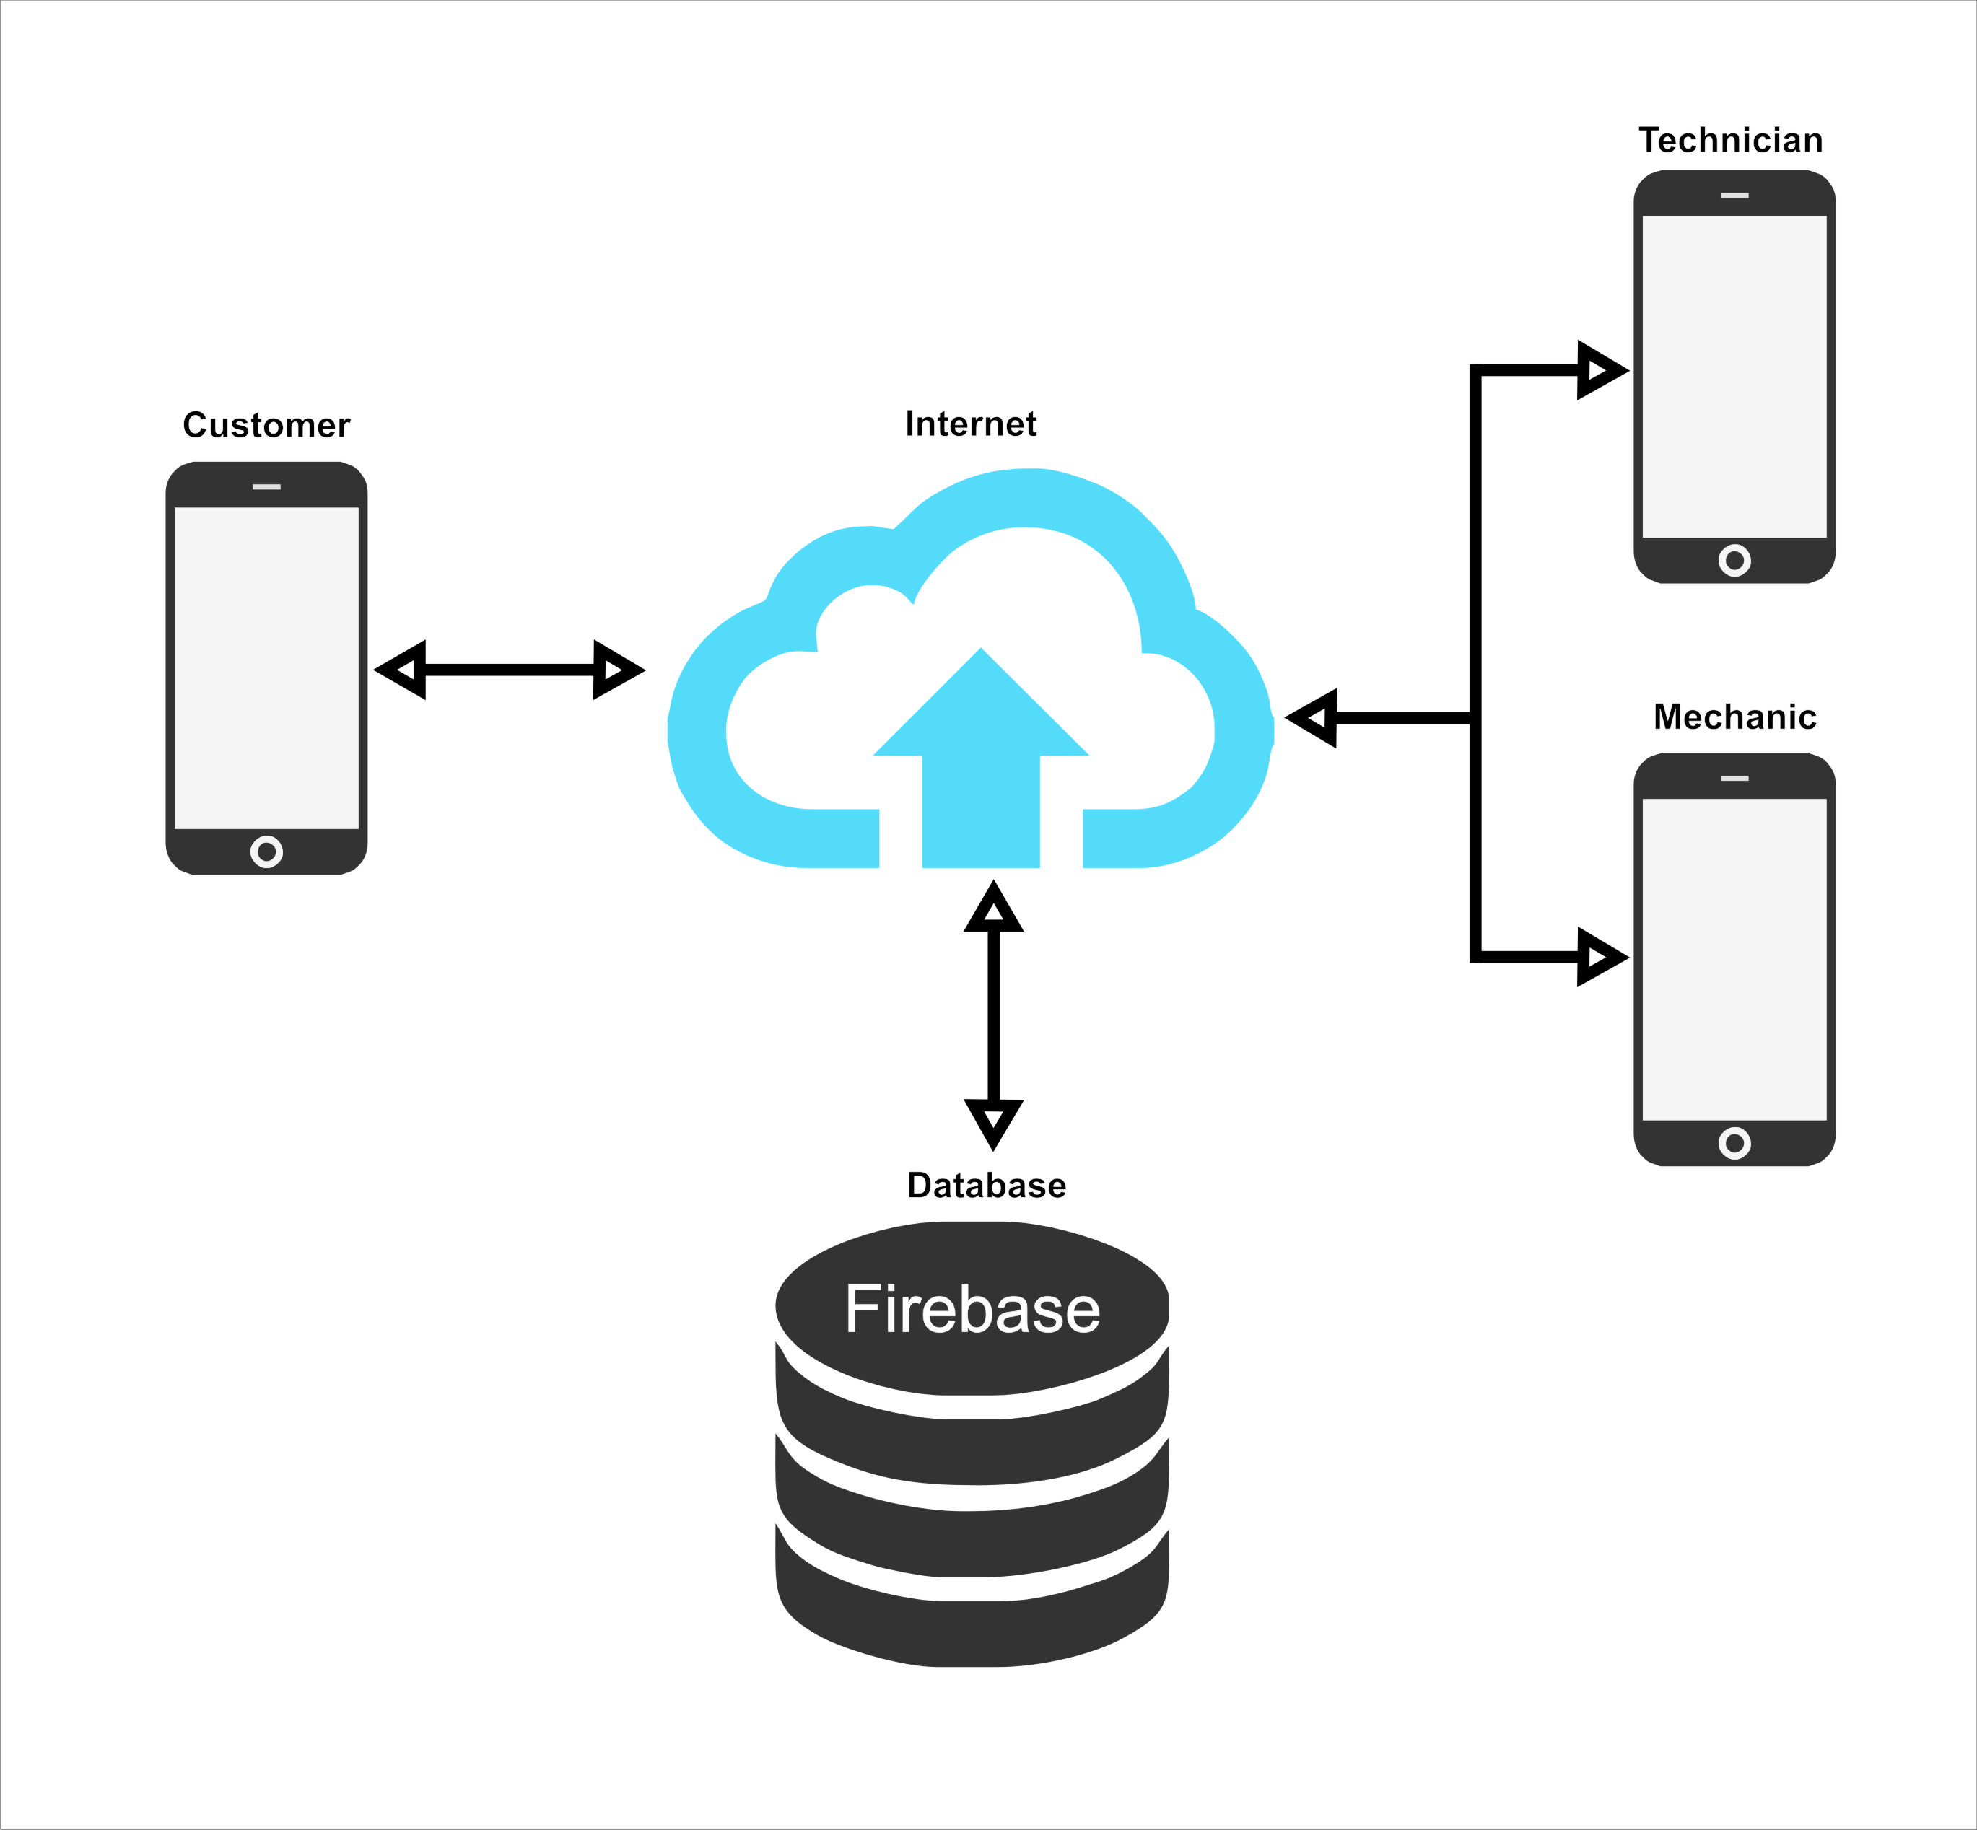

*Figure 21 High-level architecture diagrams*

3.3.2. Interface Design

All the interfaces of the HireBuddy application were designed using a user-friendly manner. Since the HireBuddy application is commonly used by many sorts of people the appearance of the interfaces is significant and it must be more attractive and simplistic as well as it will urge a different kind of people to use this application in their daily activities.

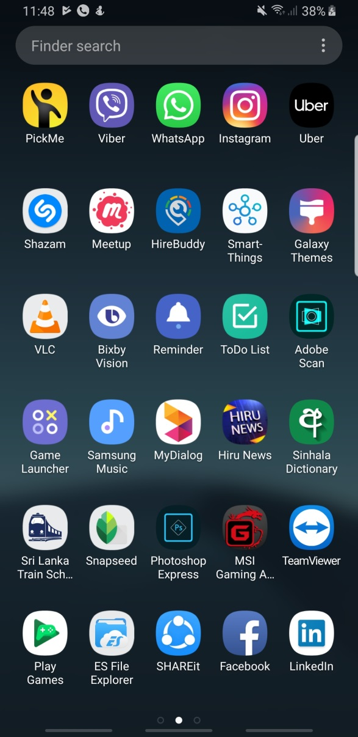The application icon is build up with the application logo and attractive color variants. When compares with the professional level applications the HireBuddy icon is also at a top level.

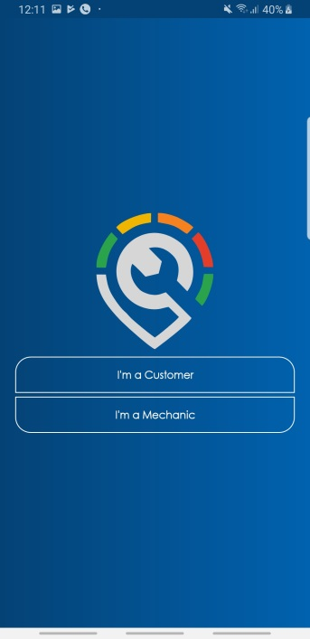When starts the application the user will be navigated to the welcome screen of the application. It consists of animating application logo and after a few seconds, the user selection screen will automatically appear.

Thereafter the user will proceed to select the login method. As to the user selection, the login activity will appear. The login activity window consists of Email and password text boxes and some user selection functions as shown in the figure.

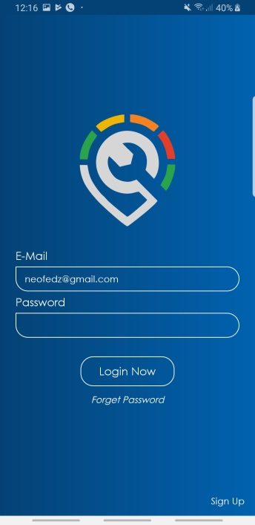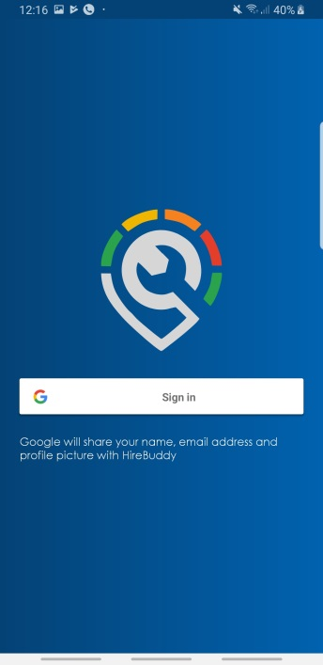

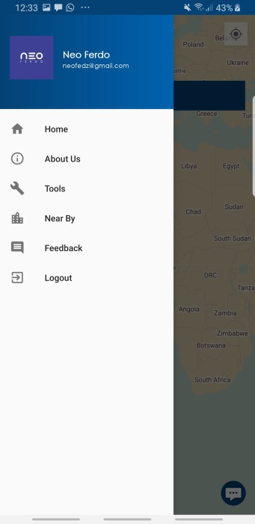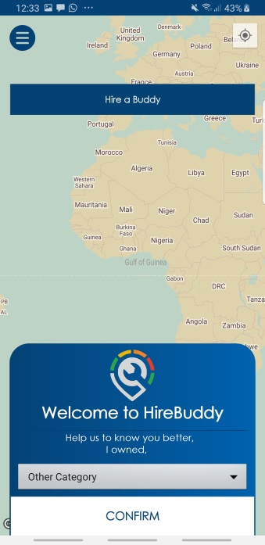After the login scenario, it will proceed to the significant interface which contains a map, navigation pane and some other objects. Once the user selects the floating button the navigation pane will appear. These components will be changed according to the user type.

The style of the map is getting change according to the system time as shown in the following figures. And the user is able to enable or disable this feature from the application options.

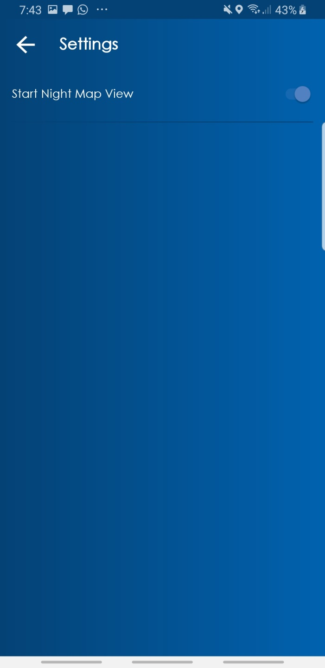

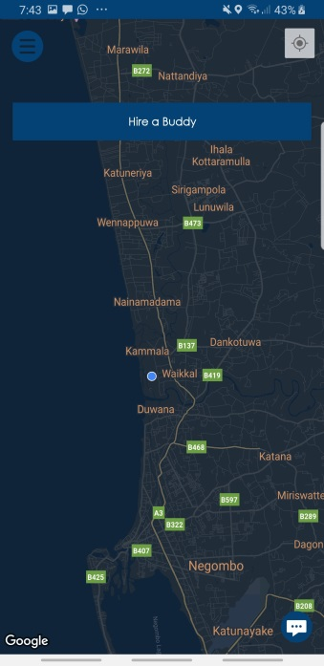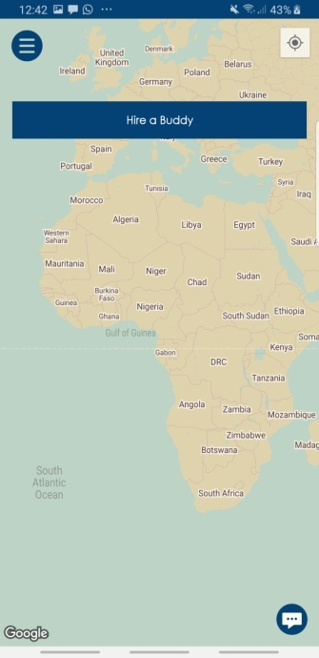

There is another interface allocated for getting user feedbacks. Since the project is following Agile Methodology it is important. Therefore the interface is designed in a simplistic manner. And it contains with

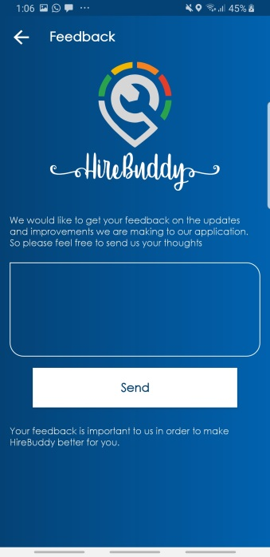

When showing nearby Police stations, Car Repair stations and Hospitals it allows the user to select the place, after that as to the selection nearby places will displays. To mark the place the application is using different types of markers.

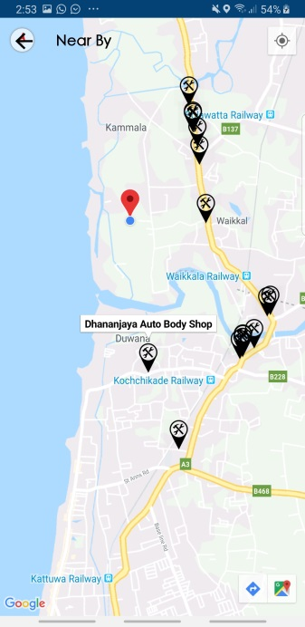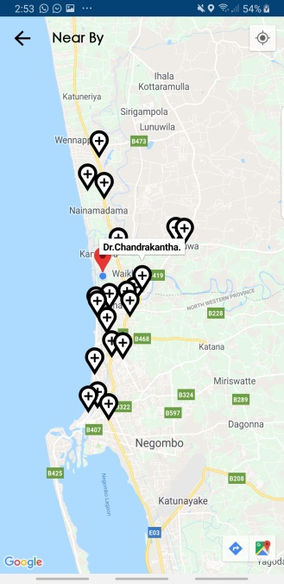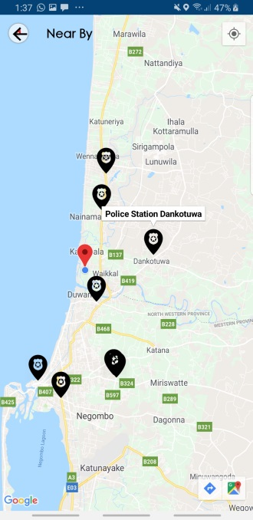

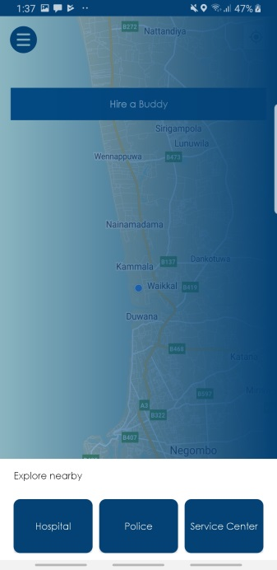

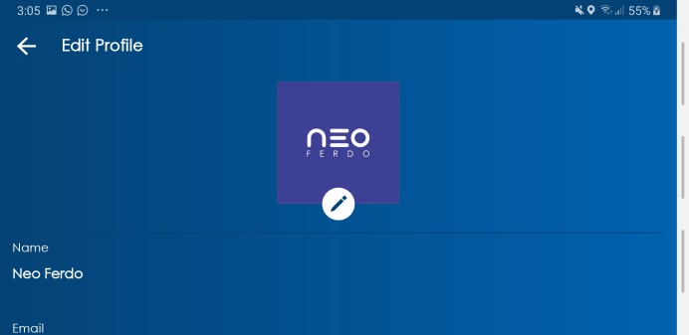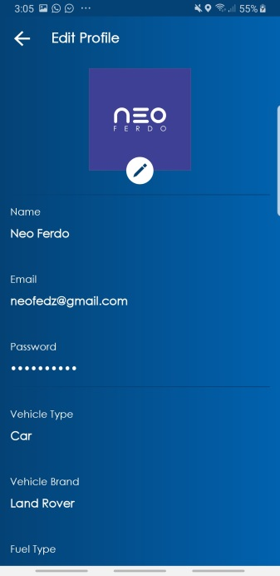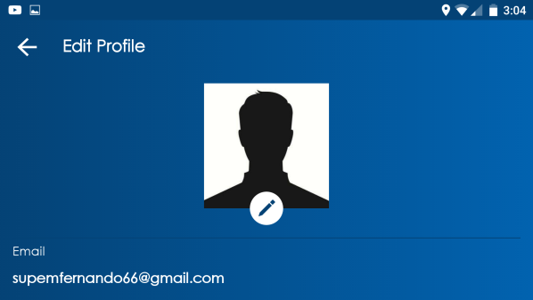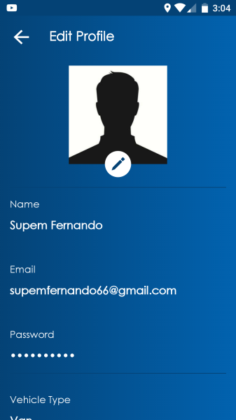Interfaces were designed to suit any type of display and any display rotation.

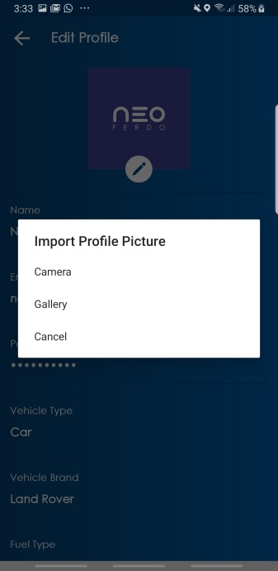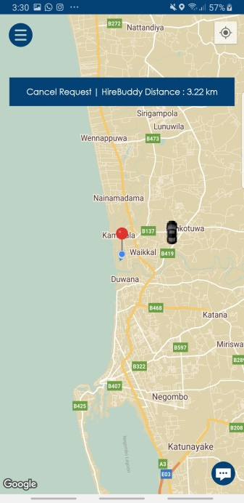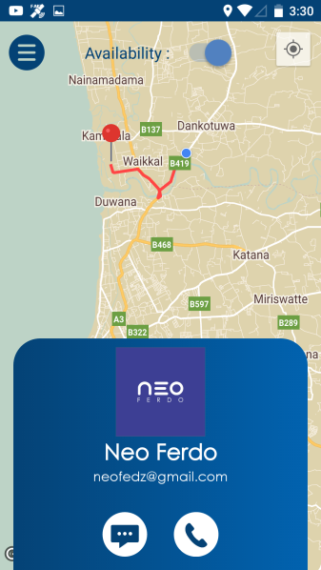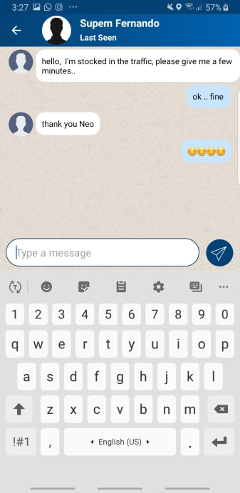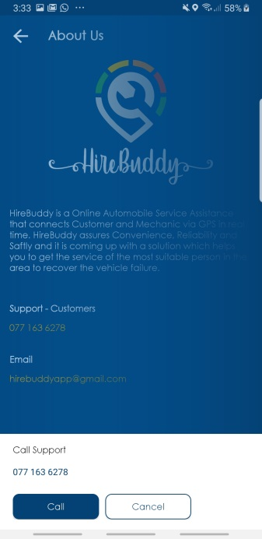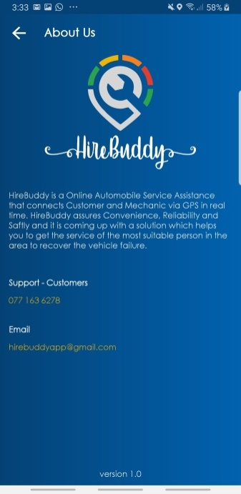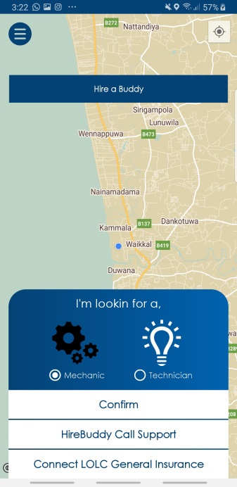Likewise, all the interfaces of the HireBuddy application were designed according to the user-friendly approach.

3.3.3. Database Design

This framework is principally relied upon information. Along these lines, keeping up a legitimate DB is fundamental. In advance the ER map was made after gathering the requirements.





27 | P a g e

*Figure 18: Main interface*



28 | P a g e

*Figure 19: Interface with floating buttons*



29 | P a g e

*Figure 20:Usecase Diagram*



30 | P a g e

*Figure 21: Activity Diagram*



31 | P a g e

*Figure 22: Flow Diagram*



32 | P a g e

3.4 Implementation

This is the phase where the analyzed requirements deployed into proposed working system. According to the GANTT chart time line and the design plan, implementation process has been completed. Step by step reach to the aim of the project by coding each and every tasks of the system. Since the application based on android environment, it has been used Android Studio to develop the project. Product was released time to time version vise under spiral model life cycle. Object Oriented Principals were used in proper manner to complete coding tasks in each version. And also it was helped to maintain quality of the code and increase efficiency of the system. Mainly Google API library used to recognize detected text from the image and some other java and android libraries used to maintain quality of the product. Other additional technologies used as follows;

* **Java language**

Java language used in suitable manner since the application based on class-oriented and object-oriented. And also it has been helped to manage entire coding segments and the efficiency of the system.

* **Android Studio**

Android Studio is the IDE which was used to code this mobile application through java language. And also this is the official IDE for the android application developments which will provides smooth service to the developer.



33 | P a g e

* **Android platform**

The main reason to select Android as the platform is, it is high accuracy open source platform. And also it is easy to popular in the market, since most of the peoples were using android base smart phones.

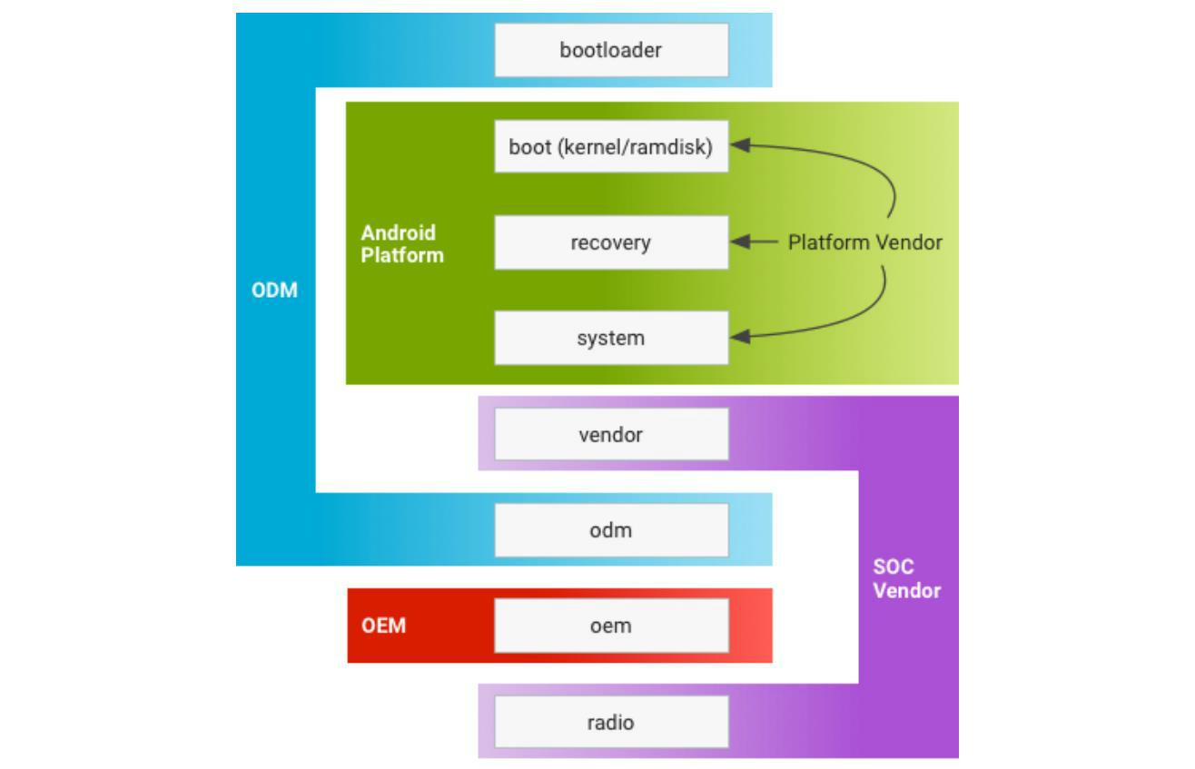

*Figure 23: graphical view of android platform*

Proposed project released version vise and every new version built according to the user feedbacks and fixed bugs for the users’ convenience. Up to now this project released 3 versions of this application and detailed implementations of each versions as bellows;



34 | P a g e

**Version 1**

This is the very first version of the application and mainly this version aimed to popular within the users by giving basic idea about the application. As the commenced version of this application, it has provided text detection function only. So it was a great opportunity to users’ check the uniqueness and effectiveness of this system.

* Detect text from digital image.
* Unit Tested.

**Implementation**

* **Select Image from gallery**

Following figure describes the selecting image from gallery and it will start the activity soon after all intent details setting completed.

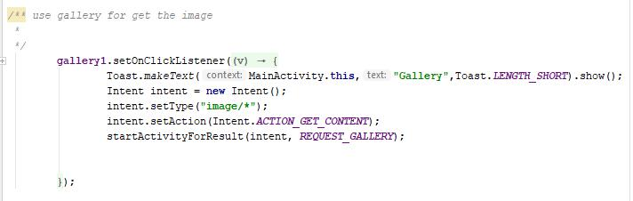

*Figure 24: Code segment for import image from gallery*



35 | P a g e

* **Capture image and save**

Before the capture an image there should be a file to save that captured image. For that it will create a file with current date time and save it in default storage. After that particular image file send to the camera event and it will extract the image uri from the image file. Finally, camera is ready to capture image and it will start the activity to capture image. Following figures will demonstrate the coding of image capturing process.

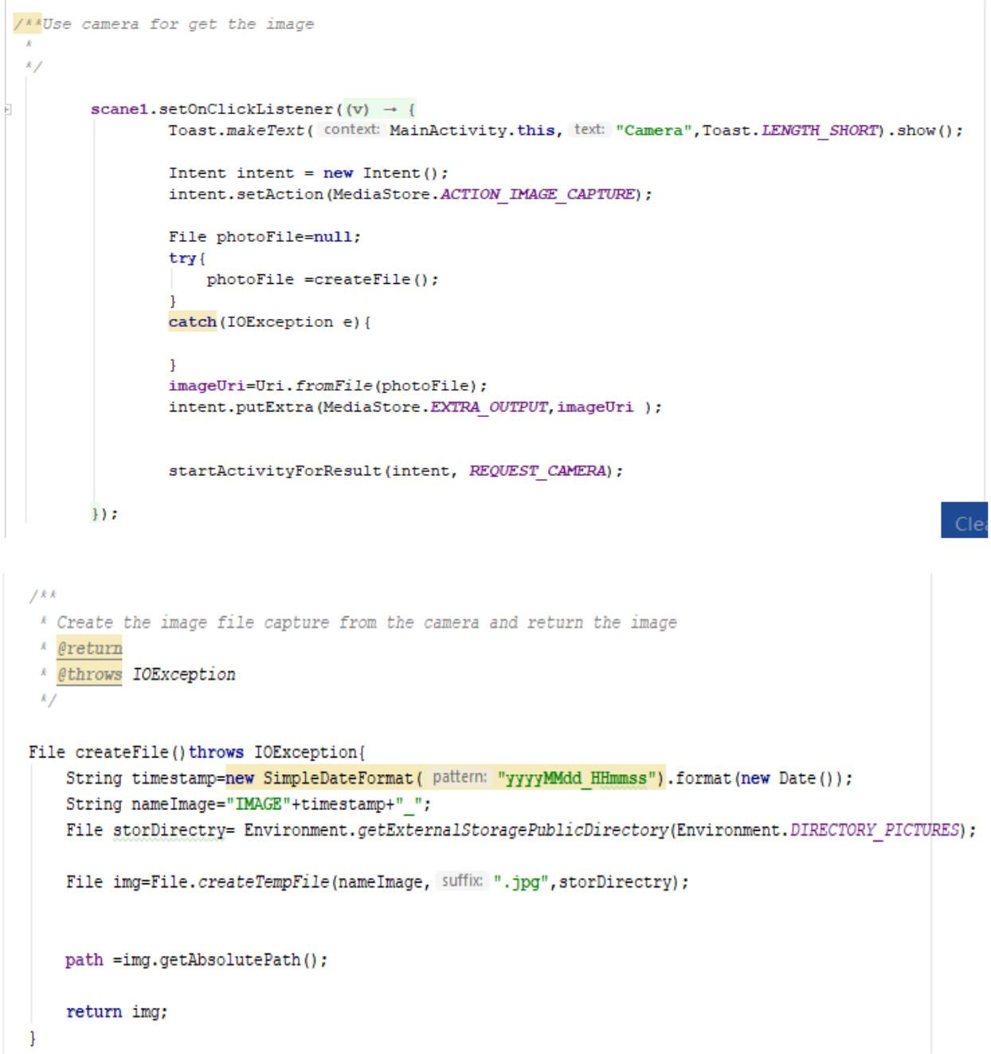

*Figure 25: Code segment for capture image from camera*



36 | P a g e

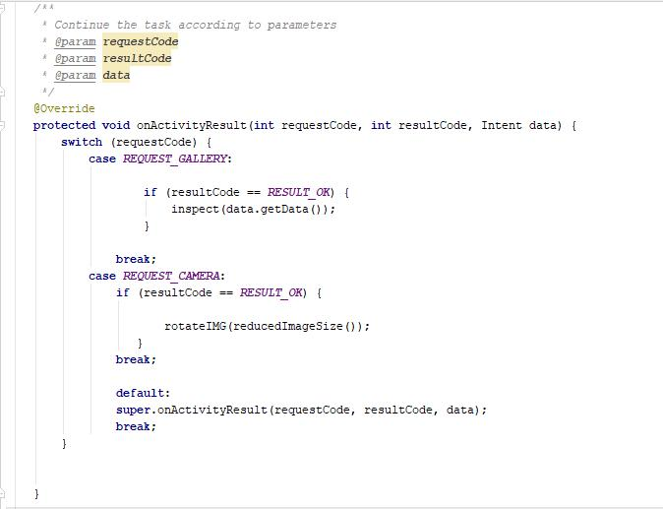

*Figure 26: Result handling*

* **Image processing**

Image quality should be high to increase text detection rate. And also image size will reduce to increase efficiency while converting it in to quality bitmap. Finally, particular Bitmap image send to correct the orientation of image. According to the EXIFINTERFACE library, the image rotates in to 0 degrees and correct the orientation of the image if it was wrong.



37 | P a g e

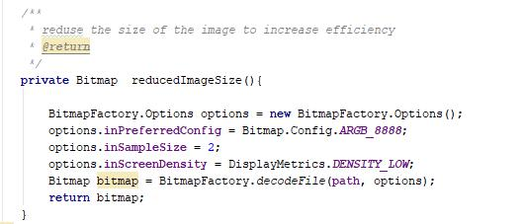

*Figure 27: process image to increase the quality*

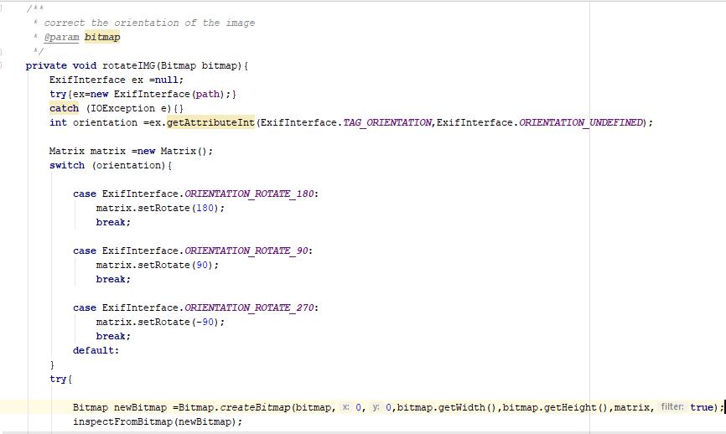

*Figure 28:Correct the image orientation*

* **Recognize text from an image**

After completion of image processing, the image will send to the recognize text. Before the recognize text, it will check the text recognizer operational or not. If it is operational, recognizer starts to extract text blocks from an image and add it in to an array. After that particular text blocks sorting in proper manner. Finally, recognized texts are appending



38 | P a g e

and final sentence set in to the text view. After completion of above process, recognizer will release. Following code segments will demonstrate the process of recognition.

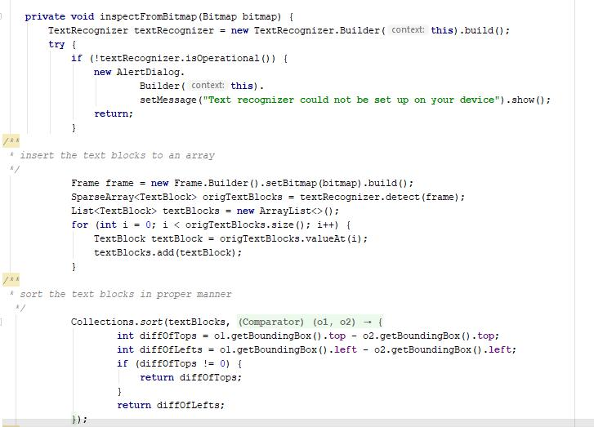

*Figure 29: Text recognition process*



39 | P a g e

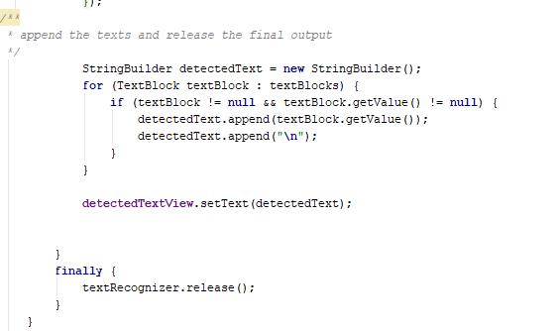

*Figure 30: Recognized text set in to text view*

**Version 2**

Version 2 released by introducing web search function to the user. With that function user able to detected text search on internet if user required additional information. Since no other OCR base application providing function to search on web, uniqueness of this application has been increased. By fixing bugs which has been occurred in version 1, effectiveness of the application has been increased.

* WEB search function.
* Unit tested.



40 | P a g e

**Implementation**

* **Web search**

Normally first sentence explains the gravity of entire paragraph. With that fact this application extracts the first sentence from detected text fields and it will send to

“goToWeb” method. Once the method called, the method will prepare the statement to search and start the activity web search. Following figures demonstrates the code of WEB search.

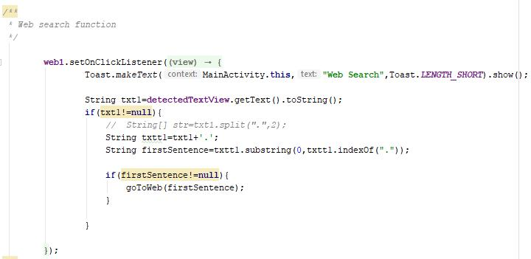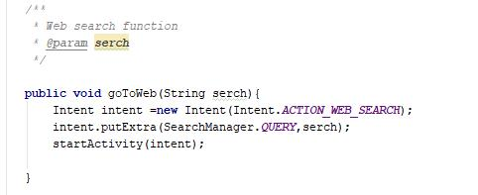

*Figure 31: Web search function*



41 | P a g e

**Version 3**

3rd version of this application has been released with introducing package of new feature to the users. In this version it has been introduced simple calculator to perform basic mathematic and Text to voice function. Moreover, for the users’ convenience it has been introduced function to speech to text also. With these new functions user able to perform basic calculations and hear output as voice. Likewise, this application offering more features to user’s convenience and according to the user feedbacks all bugs were fixed which has been occurred in previous versions.

* Perform basic calculations.
* Text to Voice.
* Speech to Text.
* Unit tested.

**Implementation**

* **Calculation**

As the first step of calculation, all white spaces are removing. To perform basic calculations, it has to be detect two numbers. So for that, this application uses simple trick. It is split the detected equation in to two by identifying special character. After identified mathematical symbol and the two numbers it will solving the equation according to identified mathematical symbol. Following figures clearly describe the process of calculation.



42 | P a g e

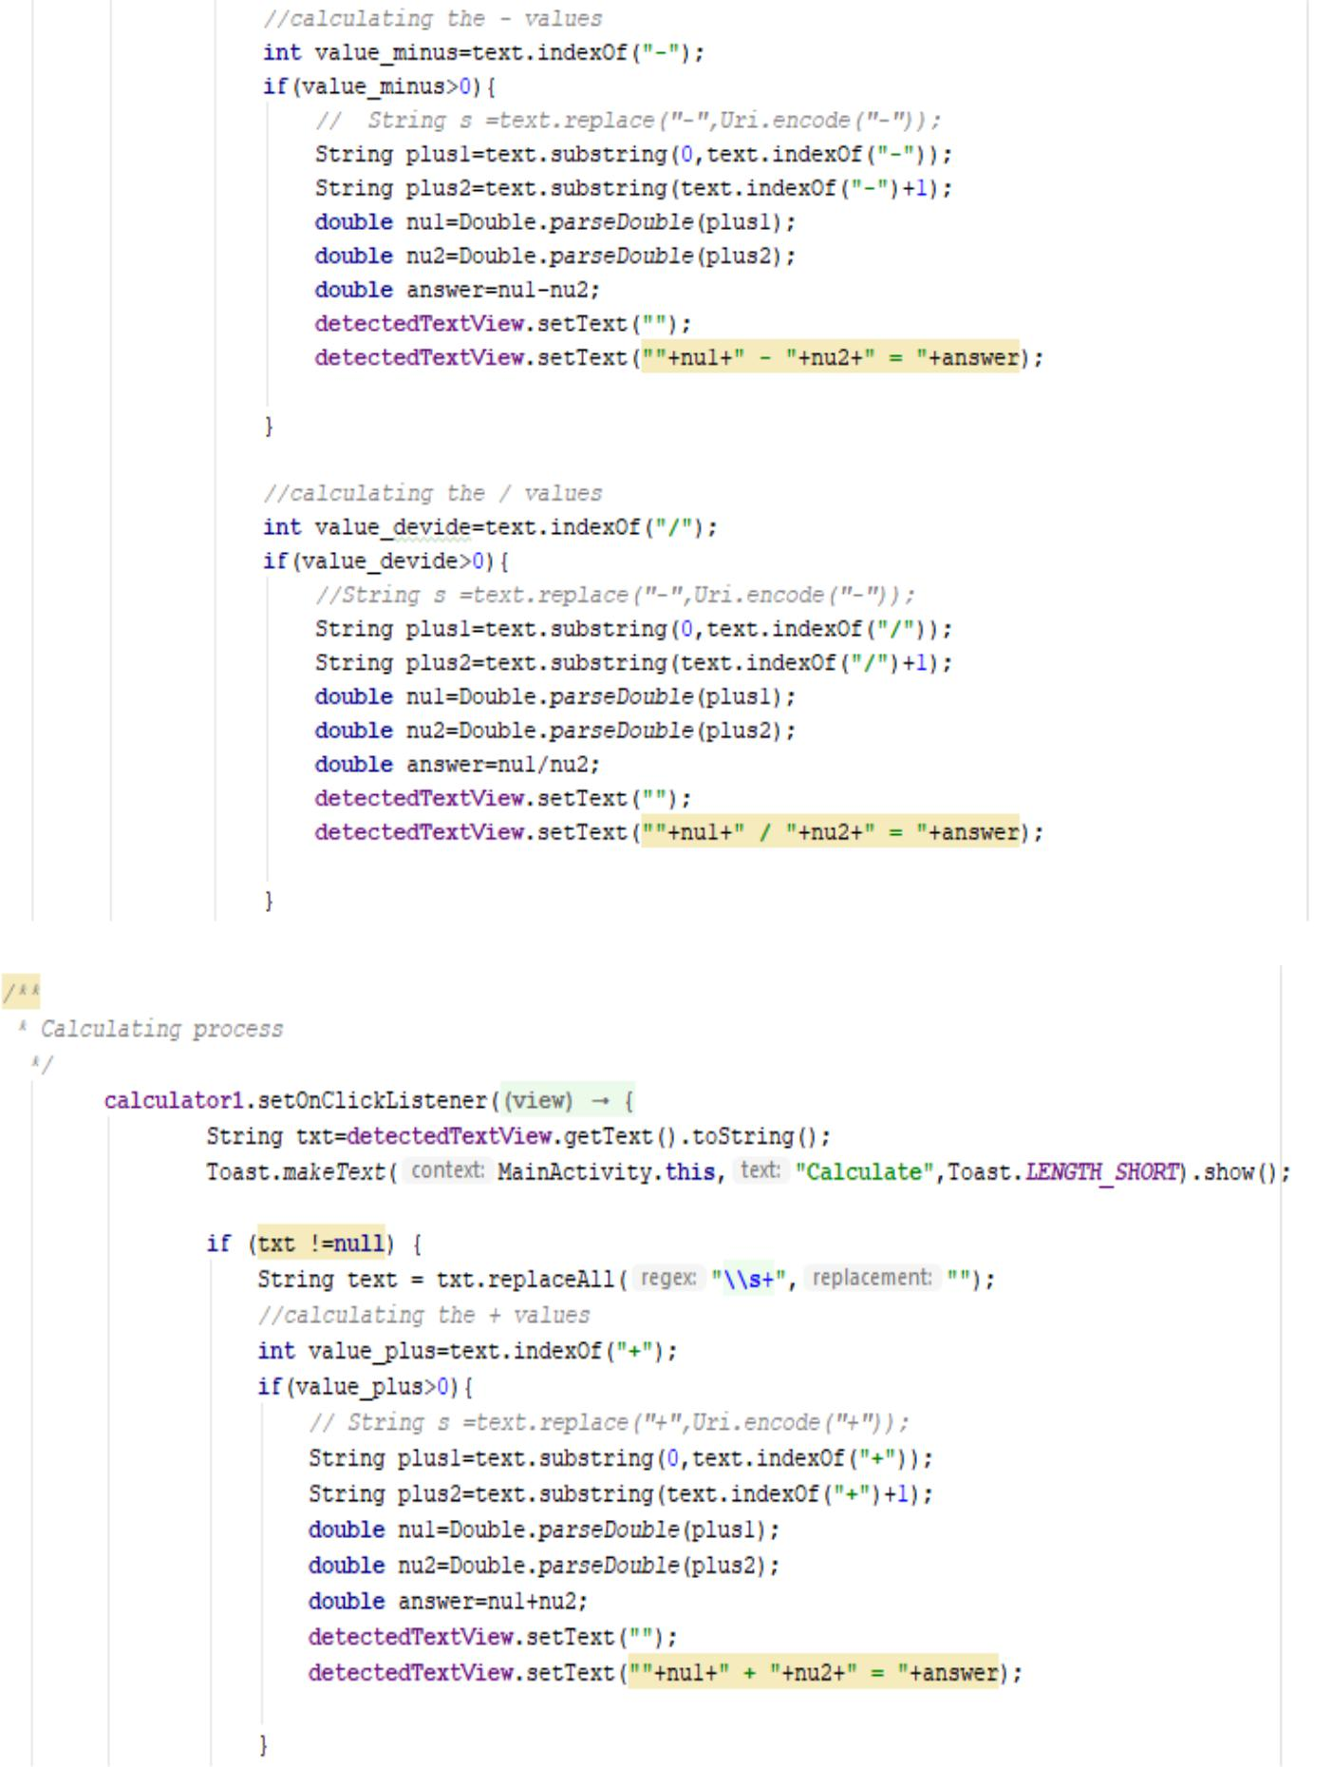

43 | P a g e

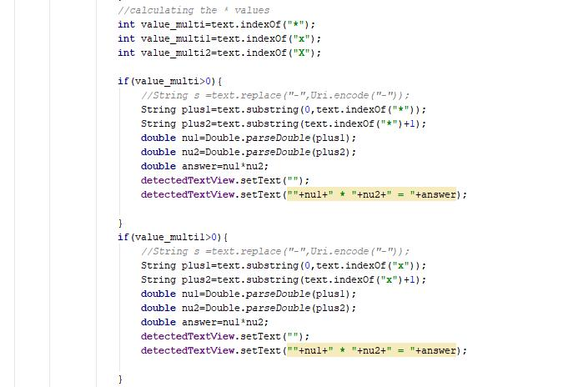

*Figure 32: Calculation process*

* **Text to voice**

Text to speech function work according to detected text view and as per the user request it will perform. Following code segment will demonstrate the process of text to speech function.



44 | P a g e

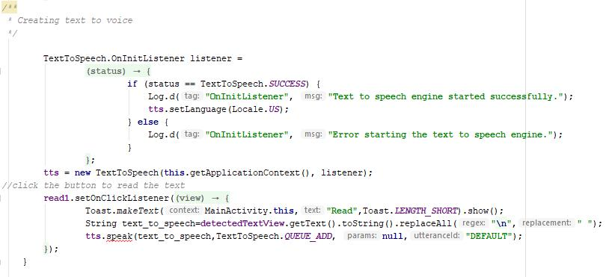

*Figure 33: Text to speech*

* **Speech to Text**

This function allows user to input the text via speech and it is very easy to visually impaired people to interact with the application. And also its efficiency is very higher than the typing text. Following code segment will demonstrate the implementation of the speech to text function.

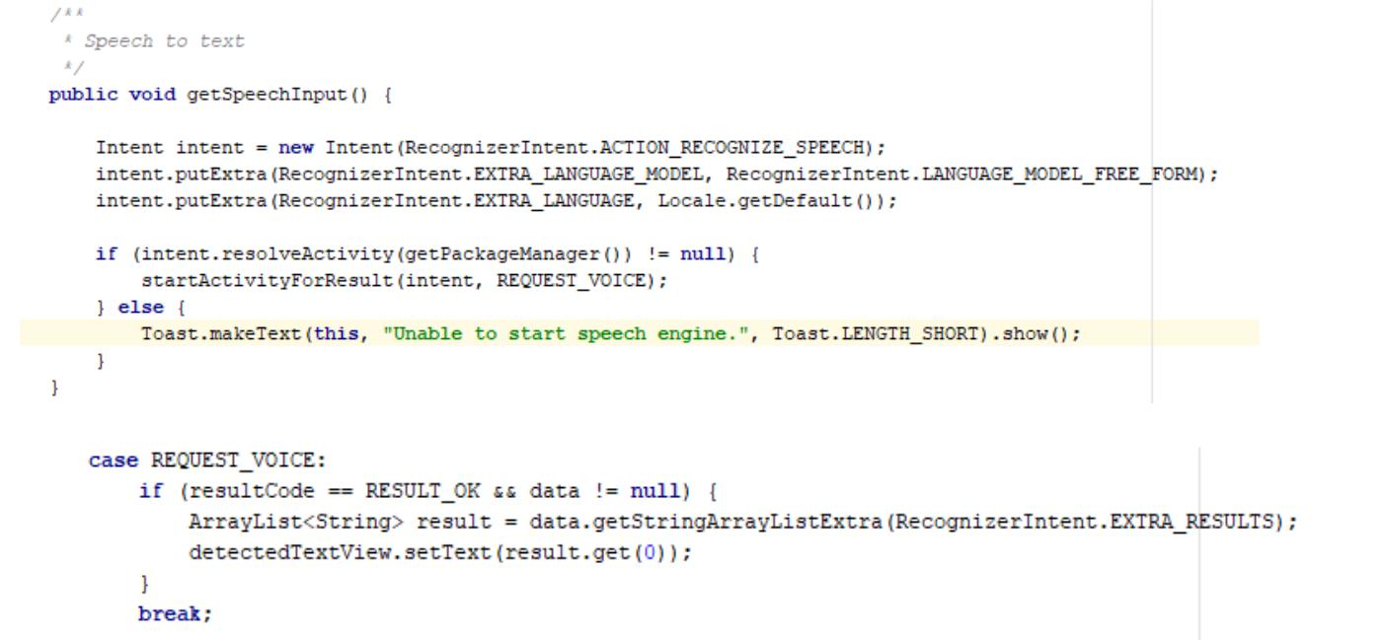

*Figure 34:Speech to text*



45 | P a g e

3.5 Testing

The system has been mainly tested under White box and usability testing methods. Before the release each version of this application, it has been tested under unit testing method to check whether all code segments and the functions work properly. According to the unit testing method each function of this application has been tested separately. Sometimes it was hard to locate errors/bugs when several functions were tested together. Code checking was depended on according to the result of particular function working or not. Once it completed, mainly focused to check the syntax errors such as invalid variable types, casting exceptions, illegal arguments and invalid parameters are belonging to syntax error checking criteria. Finally, the application tested under system testing method to verify the application meets its specified requirements. And also external interfaces, performance and the programming functionalities tested to increase the quality of this application.

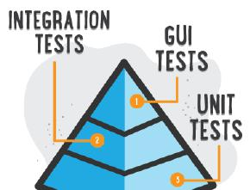

*Figure 35: Testing methods*



46 | P a g e

|  |  |  |  |
| --- | --- | --- | --- |
|  | Test Case ID | TC-001 |  |
|  |  |  |  |
|  | Test Description | Splash screen activity Starts with logo. |  |
|  |  |  |  |
|  | Test Procedure | Start the application |  |
|  |  |  |  |
|  | Input Values | - |  |
|  |  |  |  |
|  | Expected Result | Splash screen. |  |
|  |  |  |  |
|  | Actual Result | Same as expected |  |
|  |  |  |  |
|  | Status | Pass |  |
|  |  |  |  |
|  |  |  |  |
|  |  |  |  |

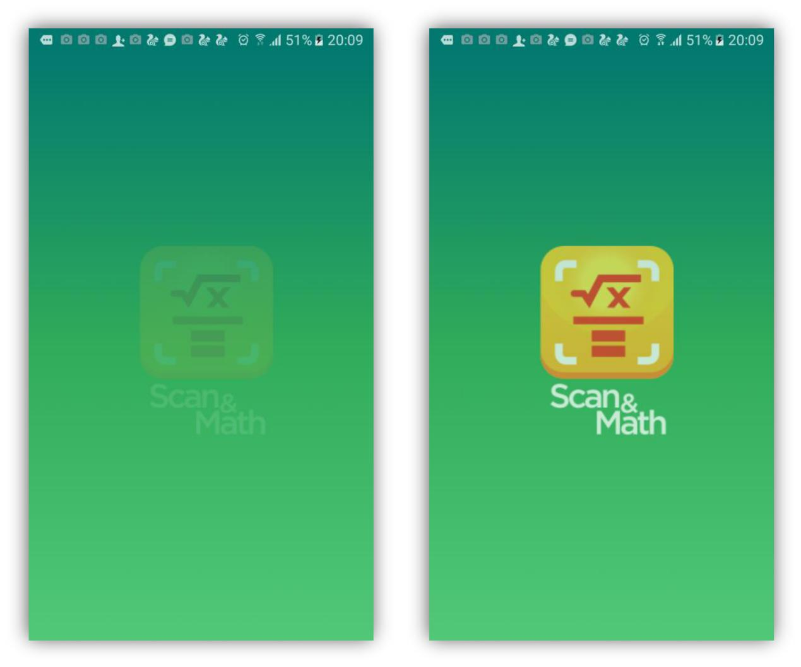

47 | P a g e

|  |  |  |  |
| --- | --- | --- | --- |
|  | Test Case ID | TC-002 |  |
|  |  |  |  |
|  | Test Description | Showing an error message when text |  |
|  |  | recognizer failed to setup |  |
|  |  |  |  |
|  | Test Procedure | Starting the application |  |
|  |  |  |  |
|  | Input Values | - |  |
|  |  |  |  |
|  | Expected Result | Display error message |  |
|  |  |  |  |
|  | Actual Result | Same as expected |  |
|  |  |  |  |
|  | Status | Pass |  |
|  |  |  |  |
|  |  |  |  |
|  |  |  |  |

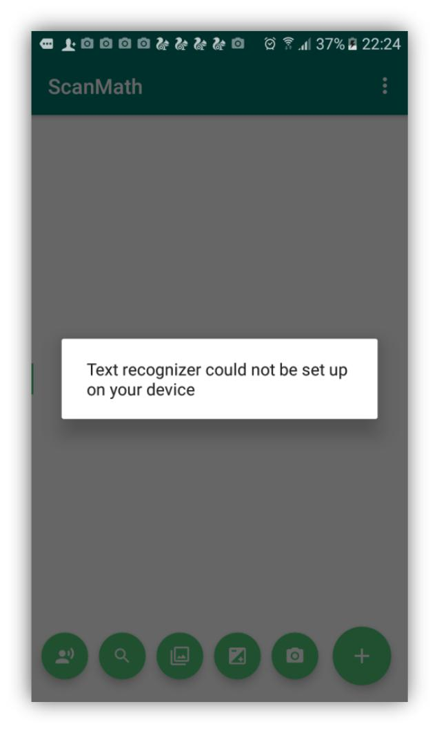

48 | P a g e

|  |  |  |  |
| --- | --- | --- | --- |
|  | Test Case ID | TC-003 |  |
|  |  |  |  |
|  | Test Description | All sub buttons will appeared when user |  |
|  |  | touches on the main floating button. |  |
|  |  |  |  |
|  | Test Procedure | Touch on the main floating button |  |
|  |  |  |  |
|  | Input Values | - |  |
|  |  |  |  |
|  | Expected Result | Appear the sub buttons |  |
|  |  |  |  |
|  | Actual Result | Same as expected |  |
|  |  |  |  |
|  | Status | Pass |  |
|  |  |  |  |
|  |  |  |  |
|  |  |  |  |

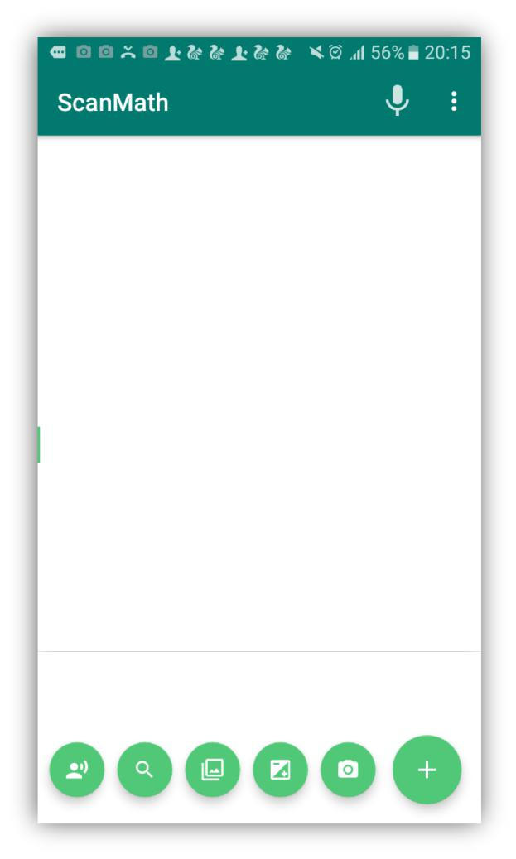

49 | P a g e

|  |  |  |  |
| --- | --- | --- | --- |
|  | Test Case ID | TC-004 |  |
|  |  |  |  |
|  | Test Description | All sub buttons will disappeared when user |  |
|  |  | touches on the main floating button. |  |
|  |  |  |  |
|  | Test Procedure | Touch on the main floating button |  |
|  |  |  |  |
|  | Input Values | - |  |
|  |  |  |  |
|  | Expected Result | Disappear the sub buttons |  |
|  |  |  |  |
|  | Actual Result | Same as expected |  |
|  |  |  |  |
|  | Status | Pass |  |
|  |  |  |  |
|  |  |  |  |
|  |  |  |  |

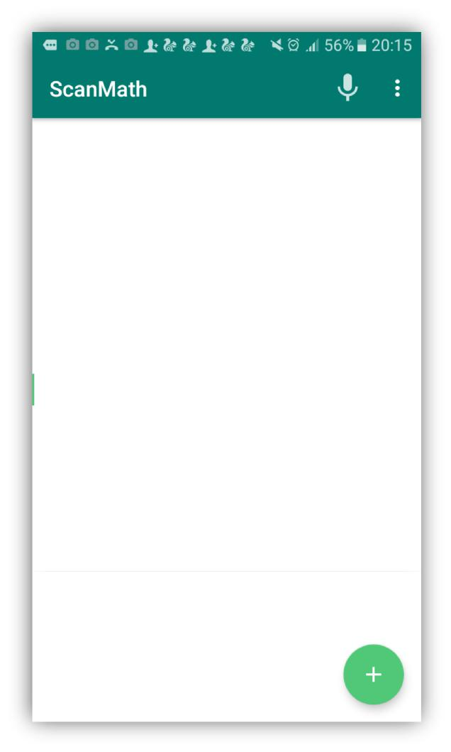

50 | P a g e

|  |  |  |  |
| --- | --- | --- | --- |
|  | Test Case ID | TC-005 |  |
|  |  |  |  |
|  | Test Description | Toast message will show once the user |  |
|  |  | touches on the button. |  |
|  |  |  |  |
|  | Test Procedure | Touch the button |  |
|  |  |  |  |
|  | Input Values | - |  |
|  |  |  |  |
|  | Expected Result | Show the toast message |  |
|  |  |  |  |
|  | Actual Result | Same as expected |  |
|  |  |  |  |
|  | Status | Pass |  |
|  |  |  |  |
|  |  |  |  |
|  |  |  |  |

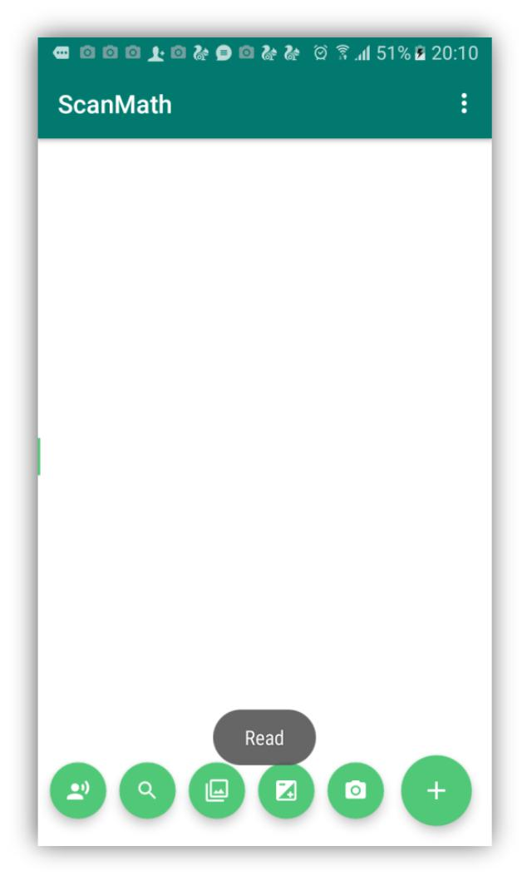

51 | P a g e

|  |  |  |  |
| --- | --- | --- | --- |
|  | Test Case ID | TC-006 |  |
|  |  |  |  |
|  | Test Description | Camera will turn on once user touches on |  |
|  |  | camera button. |  |
|  |  |  |  |
|  | Test Procedure | Touch the camera button |  |
|  |  |  |  |
|  | Input Values | - |  |
|  |  |  |  |
|  | Expected Result | Starting camera activity |  |
|  |  |  |  |
|  | Actual Result | Same as expected |  |
|  |  |  |  |
|  | Status | Pass |  |
|  |  |  |  |
|  |  |  |  |
|  |  |  |  |

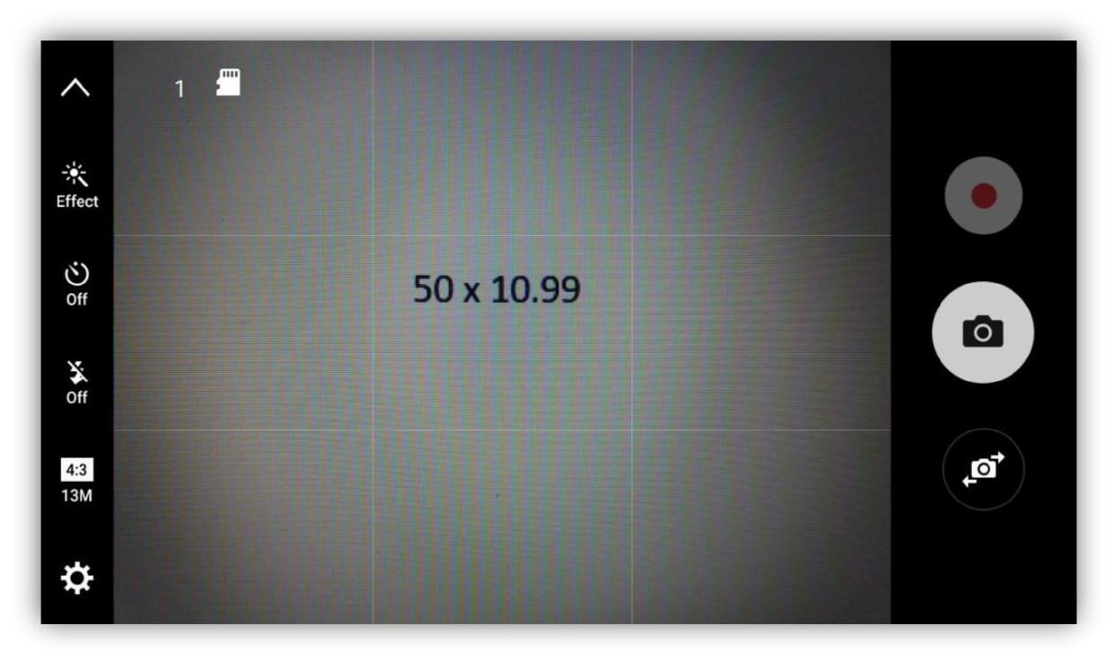

52 | P a g e

|  |  |  |  |  |
| --- | --- | --- | --- | --- |
|  | Test Case ID | TC-007 |  |  |
|  |  |  |  |  |
|  | Test Description | Once user capture the image it will asked to |  |  |
|  | retry or continue with captured image. |  |  |
|  |  |  |  |
|  |  |  |  |  |
|  | Test Procedure | Capture an image |  |  |
|  |  |  |  |  |
|  | Input Values | - |  |  |
|  |  |  |  |  |
|  | Expected Result | Ask to retry the process |  |  |
|  |  |  |  |  |
|  | Actual Result | Same as expected |  |  |
|  |  |  |  |  |
|  | Status | Pass |  |  |
|  |  |  |  |  |
|  |  |  |  |  |
|  |  |  |  |  |

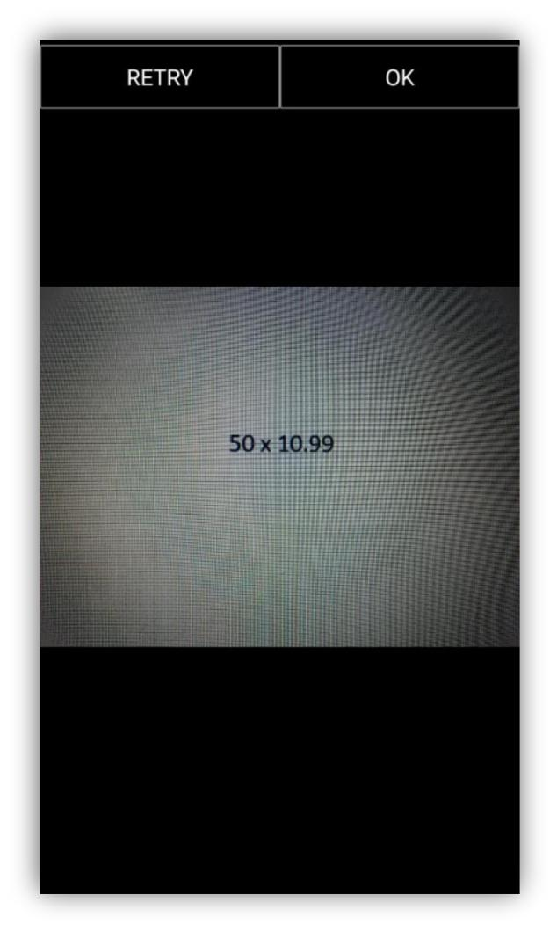

53 | P a g e

|  |  |  |  |
| --- | --- | --- | --- |
|  | Test Case ID | TC-008 |  |
|  |  |  |  |
|  | Test Description | Proceed to image gallery. |  |
|  |  |  |  |
|  | Test Procedure | Touch on gallery button |  |
|  |  |  |  |
|  | Input Values | - |  |
|  |  |  |  |
|  | Expected Result | Proceed to phone gallery |  |
|  |  |  |  |
|  | Actual Result | Same as expected |  |
|  |  |  |  |
|  | Status | Pass |  |
|  |  |  |  |
|  |  |  |  |
|  |  |  |  |

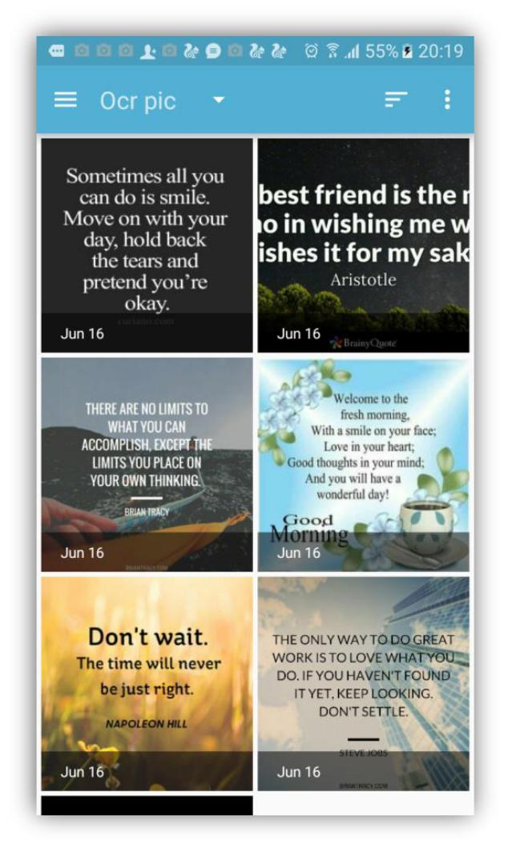

54 | P a g e

|  |  |  |  |
| --- | --- | --- | --- |
|  | Test Case ID | TC-009 |  |
|  |  |  |  |
|  | Test Description | Recognize the text from digital image. |  |
|  |  |  |  |
|  | Test Procedure | Capture or select image from gallery |  |
|  |  |  |  |
|  | Input Values | - |  |
|  |  |  |  |
|  | Expected Result | Show the recognized text on text view. |  |
|  |  |  |  |
|  | Actual Result | Same as expected |  |
|  |  |  |  |
|  | Status | Pass |  |
|  |  |  |  |
|  |  |  |  |
|  |  |  |  |

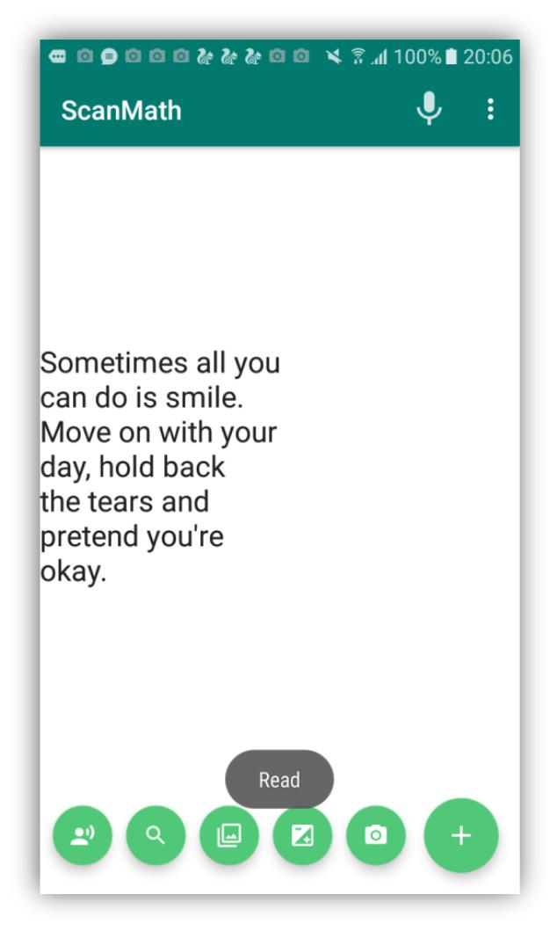

55 | P a g e

|  |  |  |  |
| --- | --- | --- | --- |
|  | Test Case ID | TC-010 |  |
|  |  |  |  |
|  | Test Description | Allow user to edit, copy and cut the |  |
|  |  | recognized text |  |
|  |  |  |  |
|  | Test Procedure | Recognize the text from image |  |
|  |  |  |  |
|  | Input Values | - |  |
|  |  |  |  |
|  | Expected Result | Suggest features to edit, copy, cut |  |
|  |  |  |  |
|  | Actual Result | Same as expected |  |
|  |  |  |  |
|  | Status | Pass |  |
|  |  |  |  |
|  |  |  |  |
|  |  |  |  |

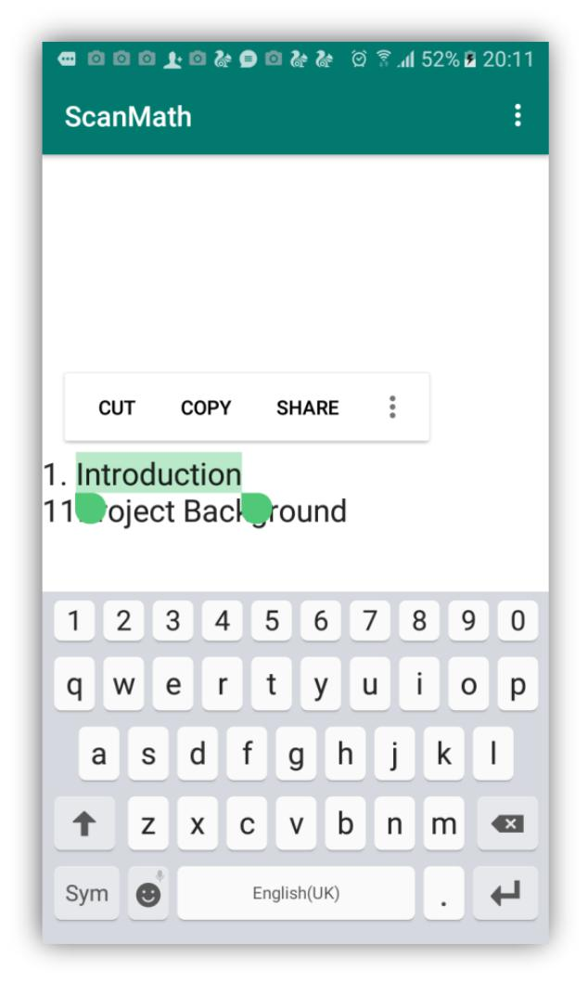

56 | P a g e

|  |  |  |  |
| --- | --- | --- | --- |
|  | Test Case ID | TC-011 |  |
|  |  |  |  |
|  | Test Description | User allow to translate the recognized text |  |
|  |  | through google translator.(This extra |  |
|  |  | feature enable only with google translator |  |
|  |  | installed devices) |  |
|  |  |  |  |
|  | Test Procedure | Select the text which user require to |  |
|  |  | translate |  |
|  |  |  |  |
|  | Expected Result | Show translated text |  |
|  |  |  |  |
|  | Actual Result | Same as expected |  |
|  |  |  |  |
|  | Status | Pass |  |
|  |  |  |  |
|  |  |  |  |
|  |  |  |  |

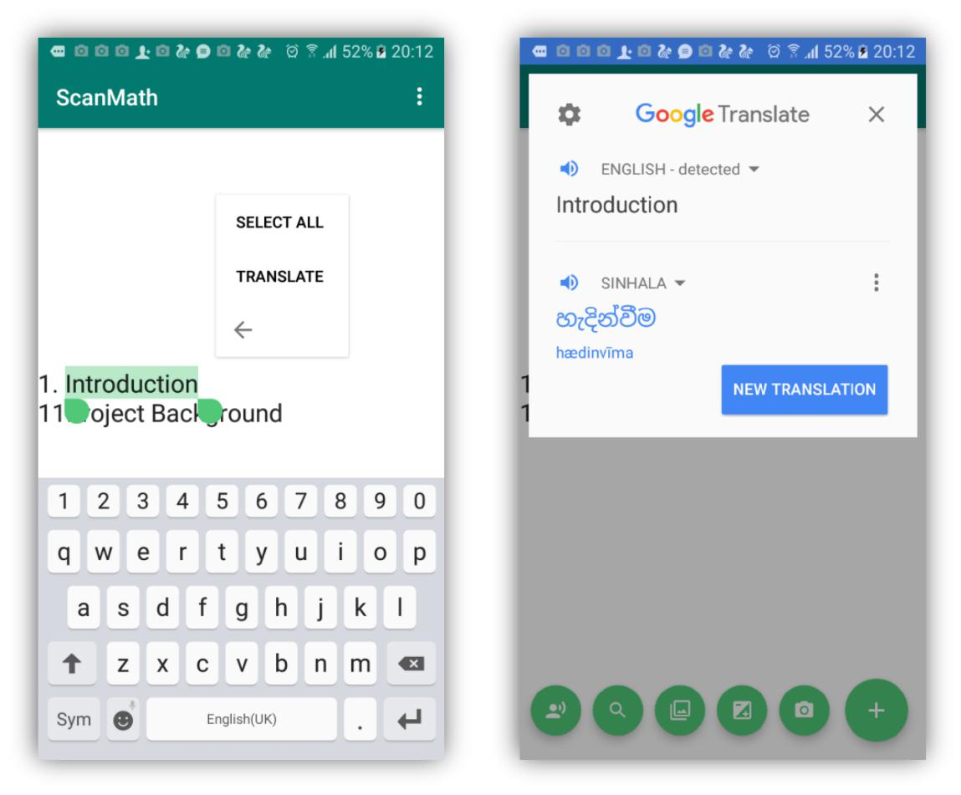

57 | P a g e

|  |  |  |  |
| --- | --- | --- | --- |
|  | Test Case ID | TC-012 |  |
|  |  |  |  |
|  | Test Description | Application process simple calculation. |  |
|  |  |  |  |
|  | Test Procedure | Capture the equation and touch the |  |
|  |  | calculate button |  |
|  |  |  |  |
|  | Input Values | - |  |
|  |  |  |  |
|  | Expected Result | Display results according to the equation. |  |
|  |  |  |  |
|  | Actual Result | Same as expected |  |
|  |  |  |  |
|  | Status | Pass |  |
|  |  |  |  |
|  |  |  |  |
|  |  |  |  |

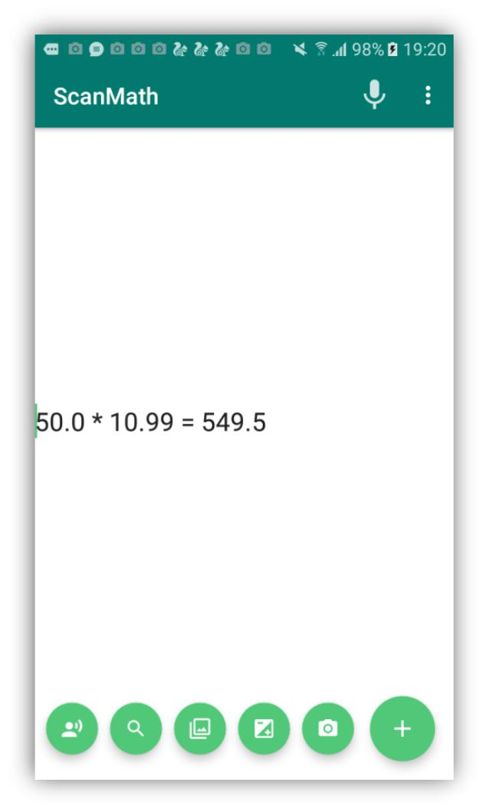

58 | P a g e

|  |  |  |  |
| --- | --- | --- | --- |
|  | Test Case ID | TC-013 |  |
|  |  |  |  |
|  | Test Description | Recognized text search on the web. |  |
|  |  |  |  |
|  | Test Procedure | Capture or select image from gallery |  |
|  |  |  |  |
|  | Input Values | - |  |
|  |  |  |  |
|  | Expected Result | Show searched results. |  |
|  |  |  |  |
|  | Actual Result | Same as expected |  |
|  |  |  |  |
|  | Status | Pass |  |
|  |  |  |  |
|  |  |  |  |
|  |  |  |  |

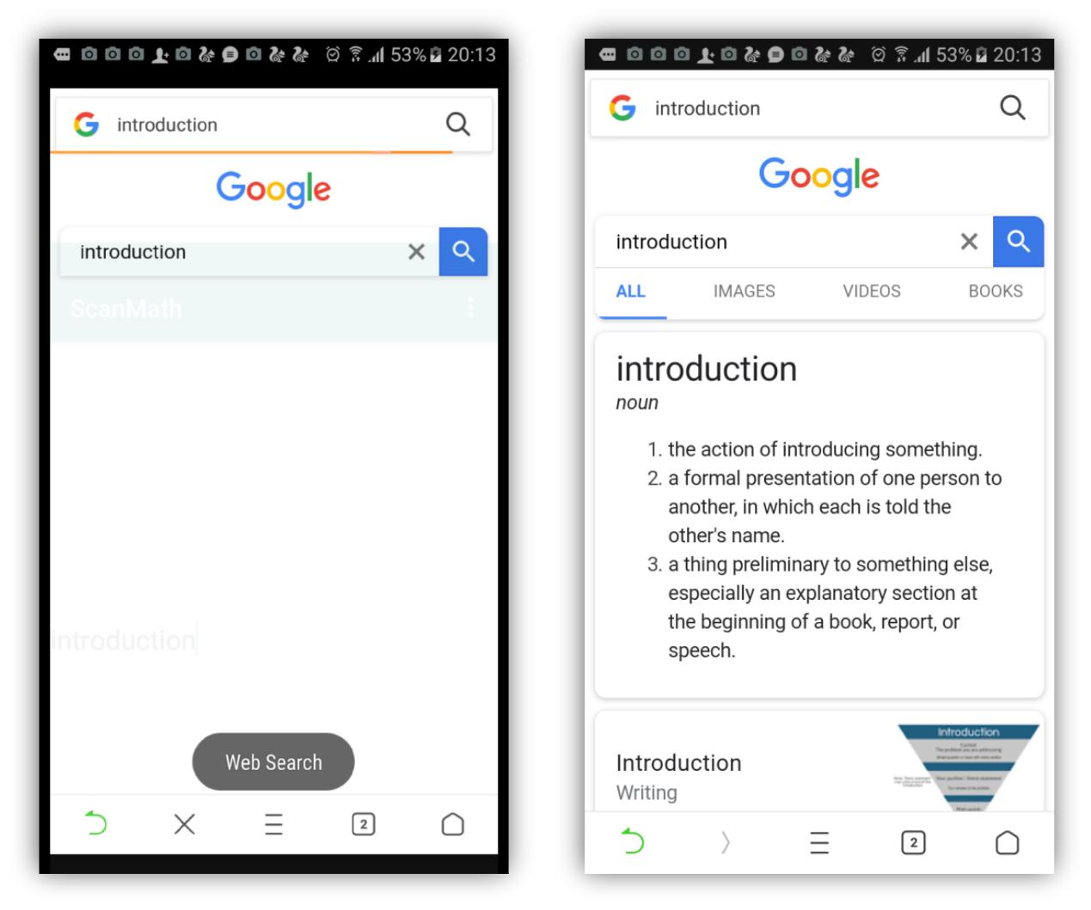

59 | P a g e

|  |  |  |  |
| --- | --- | --- | --- |
|  | Test Case ID | TC-014 |  |
|  |  |  |  |
|  | Test Description | Read the recognized text(Voice output). |  |
|  |  |  |  |
|  | Test Procedure | Capture or select image from gallery |  |
|  |  |  |  |
|  | Input Values | - |  |
|  |  |  |  |
|  | Expected Result | Voice output. |  |
|  |  |  |  |
|  | Actual Result | Same as expected |  |
|  |  |  |  |
|  | Status | Pass |  |
|  |  |  |  |
|  |  |  |  |
|  |  |  |  |



60 | P a g e

|  |  |  |  |
| --- | --- | --- | --- |
|  | Test Case ID | TC-015 |  |
|  |  |  |  |
|  | Test Description | Voice input shown as the text output in |  |
|  |  | editable way |  |
|  |  |  |  |
|  | Test Procedure | Once user click the mic button user will able |  |
|  |  | to give voice input |  |
|  |  |  |  |
|  | Input Values | Voice input |  |
|  |  |  |  |
|  | Expected Result | Text output. |  |
|  |  |  |  |
|  | Actual Result | Same as expected |  |
|  |  |  |  |
|  | Status | Pass |  |
|  |  |  |  |
|  |  |  |  |
|  |  |  |  |

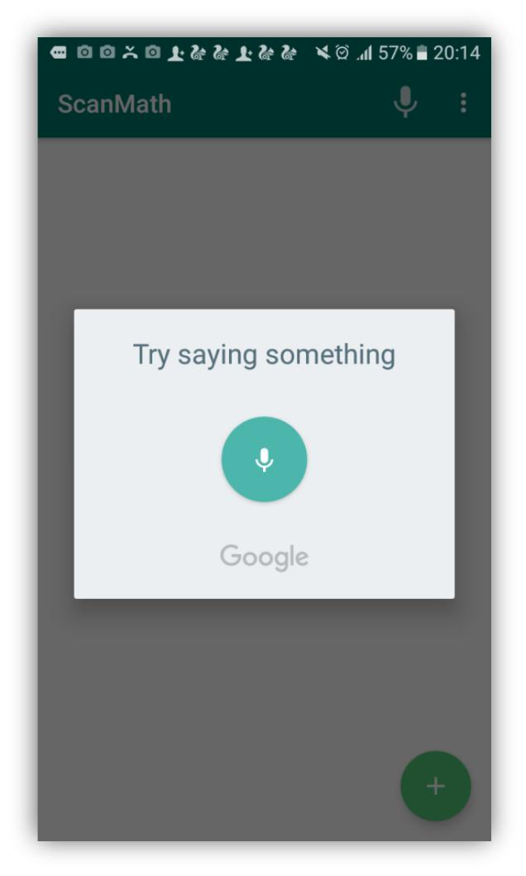

61 | P a g e

3.6 Evaluation

The evaluation of the proposed system, Online Automobile service platform or “HireBuddy” is based on the feedbacks of a group of exact vehicle users as well as some technicians. This group of evaluators contains some members of my family and some of SLIIT Computing students. I have selected some technicians too. The people that have selected as the evaluators are between 20 to 60 age ranges.

After the proposed system almost developed, the final product has been distributed with the technicians and vehicle users. To collect the feedbacks the system contains a feedback session. It has been added as a function of the application. User will be able to submit their feedback about the application through the feedback session.

According to the feedbacks, most of the technicians and the vehicle users are happy about the “HireBuddy” application as it is user friendly and because of the attractive interfaces. Also it is easy to understand and it won't confuse the fresh users. As indicated by the user opinions they like the functions of the proposed system as it save the time of the people with high efficiency.

The below figure describe the performances of the proposed system base on the exact user’s feedbacks;

|  |  |  |  |  |
| --- | --- | --- | --- | --- |
| **Function** | Excellent | Good | Average | Bad |
|  |  |  |  |  |
| Calculation | **✓** |  |  |  |
|  |  |  |  |  |
| Web search | **✓** |  |  |  |
|  |  |  |  |  |
| Voice to text |  | **✓** |  |  |
|  |  |  |  |  |
| Text detection |  | **✓** |  |  |
|  |  |  |  |  |
| Text to speech | **✓** |  |  |  |
|  |  |  |  |  |
| Interfaces and the | **✓** |  |  |  |
| appearance |  |  |  |  |
|  |  |  |  |  |
|  | *Figure 36:Performences of the application* | |  |  |



63 | P a g e

The following table displays some comments given by the exact uses as indicated by their experiences with “HireBuddy” application.

|  |  |
| --- | --- |
| **No.** | **Comment** |
|  |  |
| 01. | Perfect and invaluable tool for those of us who get overwhelmed by large blocks of |
|  | text |
|  |  |
| 02. | The app is great but it would be better if you add a feature that the scanner should |
|  | detect the hand written equations. However, it is still helpful and hope for development |
|  | on my suggestion. |
|  |  |
| 03. | Best app ever for converting images into text. Tremendously useful for teachers, |
|  | students and visually impaired people. Loved it. |
|  |  |
| 04. | Some Words recognize Wrongly. But it's ok. At least, it's quite better comparison to |
|  | other similar apps. Thanks |
|  |  |
| 05. | This app is awesome! It was really useful and besides from the camera that could solve |
|  | any problem, it also had a regular calculator function and ability. Great work! |
|  |  |
| 06. | it's effective application but It will make a few mistakes depending on text font and |
|  | image quality, but still fantastic. |
|  |  |
| 07. | Application is offering attractive bundle of features. Web search function is my |
|  | favorite. |

1. Really useful... Just as good as a physical calculator. Solving equations with camera would help a lot
   1. The interfaces of this application is user friendly and easy to use. appearance also

nice. Great job.

*Figure 37: Comments given by the users*



64 | P a g e

Chapter 04: Results and Discussions

* **Accuracy and the performance**

“Scan&Math” is mainly focuses to help visually impaired people and the other people also can beneficial through this application in their day-to-day tasks. Since the application uses the latest OCR libraries, the accuracy and the performance are very high. To increase the accuracy of this application image quality has been increased by using suitable image processing techniques. URI (Uniform Resource Identifier) has been used to identify correct path of the image. Because URI is a string which refers directly to the resource.

Always high performance and the effectiveness are the key features of a quality product. With that fact, the interfaces of this product were designed user friendly and easy to use manner to increase user performance through this application. And also image size was reduced before the process. Because process time will depend on size of the image. Therefore, images with small sizes are process fast than the large size of images and that process time will directly affect to the performance of the application. Furthermore, it has been used URI to find location of the image file and it is very fast method than searching file through its path. Likewise, this application used so many strategies to increase performance and the accuracy of the system.

* **Technical problems**

Technical problems are the most common problems which occurs during the software life time. Since the project mainly focuses visually impaired people and had to concern their needs and the daily tasks. When it comes to the development process of the project, initially gathered requirements were insufficient. So it has to gather requirement data



65 | P a g e

again. If the requirements were not good, project will fail and people will hate the result. With that fact conduct another few interviews to gather complete and correct requirements.

Bugs-free software does not exist in the world. As the above statement, when it comes to the testing phase there was an error in orientation of the image. The images capture through OCR camera were always process with incorrect orientation. Therefore, its unable to detect text from the captured images. To overcome from this problem, it has been used EXIFINTERFACE library. And with that library it was able to correct the orientation of the captured image. It cost more time to overcome with the issue and project time plan was deviated. To balance with project time plan, step by step reduce the extra time which allocated to implementation of small functions. With that solution it was able to balance with the project time plan and finish the project before the dead line.

Chapter 05: Conclusion

5.1 Benefits

“Scan&Math” is a product which is developed to help visually impaired people in their daily tasks. But with the performance and the accuracy, all other people also can beneficial from this application. Basically this application scans the text from the digital image and process it in to editable text. Therefore, user able to edit the text and copy past it as the user’s requirement. And also if user required additional information about the scanned text, user able to simply search it on the web through this application. With the use of Scan & Math the user able to work out



66 | P a g e

simple arithmetic problems by capturing an image of the specific equation. Furthermore, application able to give voice output of all scanned texts and the answers which solve by the calculate function. Likewise, it offering package of functions and beneficial for all Scan&Math users.

5.2 Limitations

Currently this application developed to solve simple mathematical equations only. It cannot solve long equations with multiple arithmetic symbols. As discussed in evaluation chapter this feature was a missed part of this application. And also it is unable to capture customized area by targeting single text or the equation. It is one of the main defect of this application and most of the user suggest to add this feature in future. Likewise, these are the main limitations of this application and according to the user feedbacks these functions are willing to develop in future.

5.3 Summery

This is the final thesis report of “Scan&Math” android based application. The report mainly consists of 5 chapters and each chapter described the background processes of the “Scan& Math” application such as project background, requirement gathering and analyzing, design of the project, testing and last evaluation of the project. Moreover, it will provide a detail discussion about the project by highlighting performance, accuracy and the technical problems. As the commencing stage, there were identified 3 main objectives according to fulfill the aim of the project and by successfully achieving each one of them completed the entire project. Even through in some versions failed to complete entire function within the allocated time according to GANTT chart because of some problem occurred and have to overcome with them. But at the



67 | P a g e

end, it has been successfully developed the entire project and evaluate it before the deadline. There were some problems occurred in the development process and manage to overcome with them by following proper testing and coding standards. Likewise, the final result of the project “Scan&Math” will beneficial for the visually impaired people and all other people.

5.5 Feature works

In the future, this application will upload to the google play store and people can beneficial by using this application. And also there is a possibility to release new version by adding fabulous features to the current system. With that fact it is supposed to add modifications such as detect hand written texts, procedure to solve long equations with multiple arithmetic symbols and adding a feature to capture customized area by the user. Likewise, with these features user will able to be more beneficial than the current system.

References

Anandhi, N. and Avudaiammal, R., 2017, April. Segmentation and recognition of text from image using pattern matching. In *Communication and Signal Processing (ICCSP), 2017 International* *Conference on* (pp. 0066-0069). IEEE.

Arik, S.O., Chrzanowski, M., Coates, A., Diamos, G., Gibiansky, A., Kang, Y., Li, X., Miller, J., Raiman, J., Sengupta, S. and Shoeybi, M., 2017. Deep voice: Real-time neural text-to-speech. *arXiv* *preprint arXiv:1702.07825*.



68 | P a g e

Boehm, B.W., 1988. A spiral model of software development and enhancement. *Computer*, *21*(5), pp.61-72.

Brisinello, M., Grbić, R., Pul, M. and Anđelić, T., 2017, September. Improving optical character recognition performance for low quality images. In *ELMAR, 2017 International Symposium* (pp. 167-171). IEEE.

Chandarana, J. and Kapadia, M., 2014. Optical character recognition. *International Journal of* *Emerging Technology and Advanced Engineering*, *4*(5), pp.219-223.

Chandio, A.A., Pickering, M. and Shafi, K., 2018, March. Character classification and recognition for Urdu texts in natural scene images. In *Computing, Mathematics and Engineering Technologies* *(iCoMET), 2018 International Conference on* (pp. 1-6). IEEE.

Du, S., Ibrahim, M., Shehata, M. and Badawy, W., 2013. Automatic license plate recognition (ALPR): A state-of-the-art review. *IEEE Transactions on circuits and systems for video* *technology*, *23*(2), pp.311-325.



69 | P a g e

Fleizach, C.B. and Hudson, R.D., Apple Inc, 2015. *Intelligent text-to-speech conversion*. U.S. Patent 8,996,376.

Hamadneh, I.M. and Al-Masaeed, A., 2015. Math teachers' attitudes towards photo math application in solving mathematical problem using mobile camera. *Educational Research and* *Reviews*, *10*(14), p.1930.

Jaderberg, M., Simonyan, K., Vedaldi, A. and Zisserman, A., 2014. Synthetic data and artificial neural networks for natural scene text recognition. *arXiv preprint arXiv:1406.2227*.

Kakani, B.V., Gandhi, D. and Jani, S., 2017, July. Improved OCR based automatic vehicle number plate recognition using features trained neural network. In *2017 8th International Conference on* *Computing, Communication and Networking Technologies (ICCCNT)* (pp. 1-6). IEEE.

Manwatkar, P.M. and Yadav, S.H., 2015, March. Text recognition from images. In *Innovations in* *Information, Embedded and Communication Systems (ICIIECS), 2015 International Conference on* (pp. 1-6). IEEE.



70 | P a g e

Netzer, Y., Wang, T., Coates, A., Bissacco, A., Wu, B. and Ng, A.Y., 2011, December. Reading digits in natural images with unsupervised feature learning. In *NIPS workshop on deep learning and* *unsupervised feature learning* (Vol. 2011, No. 2, p. 5)

Ochkov, V.F. and Bogomolova, E.P., 2015. Teaching mathematics with mathematical software. *Journal of Humanistic Mathematics*, *5*(1), pp.265-285.

O'malley, S., O'malley, M.H. and Peters, E., Berkeley Speech Tech Inc, 1991. *Text-to-speech* *converter of a facsimile graphic image*. U.S. Patent 4,996,707

Pang, L., Lan, Y., Guo, J., Xu, J., Wan, S. and Cheng, X., 2016, February. Text Matching as Image Recognition. In *AAAI*(pp. 2793-2799).

Pradeepa, K. and Sivitha, M., 2014, December. Optical persona realization of tantrum text sensing, excavation and recognition. In *Computational Intelligence and Computing Research* *(ICCIC), 2014 IEEE International Conference on*(pp. 1-4). IEEE.



71 | P a g e

Pranoto, Y.M., Setyati, E., Pramana, E., Kristian, Y. and Budiman, R., 2016, July. Real time handwriting recognition for mathematic expressions using Hidden Markov Model. In *Intelligent* *Technology and Its Applications (ISITIA), 2016 International Seminar on* (pp. 1-6). IEEE.

Shastry, S., Gunasheela, G., Dutt, T., Vinay, D.S. and Rupanagudi, S.R., 2013, March. “i”—A novel algorithm for optical character recognition (OCR). In *Automation, Computing, Communication,* *Control and Compressed Sensing (iMac4s), 2013 International Multi-Conference on* (pp. 389-393).IEEE.

Song, H., Kalasapur, S., Jeong, S. and Cheng, D., 2009, January. Smartsearch: Situation-aware web search on mobile devices. In *Consumer Communications and Networking Conference, 2009. CCNC* *2009. 6th IEEE* (pp. 1-2). IEEE.

Sonka, M., Hlavac, V. and Boyle, R., 2014. *Image processing, analysis, and machine vision*.

Cengage Learning.

Taylor, P., 2009. *Text-to-speech synthesis*. Cambridge university press.



72 | P a g e

Verma, A., Arora, S. and Verma, P., 2016. OCR Optical Character Recognition. In *7th International* *Conference on Recent Innovations in Science, Engineering and Management*.

World Health Organization. (2018). *Vision impairment and blindness*. [online] Available at: http://www.who.int/news-room/fact-sheets/detail/blindness-and-visual-impairment [Accessed 11 Sep. 2018].

Ye, Q. and Doermann, D., 2015. Text detection and recognition in imagery: A survey. *IEEE* *transactions on pattern analysis and machine intelligence*, *37*(7), pp.1480-1500.

Yin, X.C., Yin, X., Huang, K. and Hao, H.W., 2014. Robust text detection in natural scene images. *IEEE transactions on pattern analysis and machine intelligence*, *36*(5), pp.970-983.

Zhang, Y.Q., Ding, Y., Xiao, J.S., Liu, J. and Guo, Z., 2012. Visibility enhancement using an image filtering approach. *EURASIP Journal on Advances in Signal Processing*, *2012*(1), p.220.



73 | P a g e

Appendix A - Interview Questions

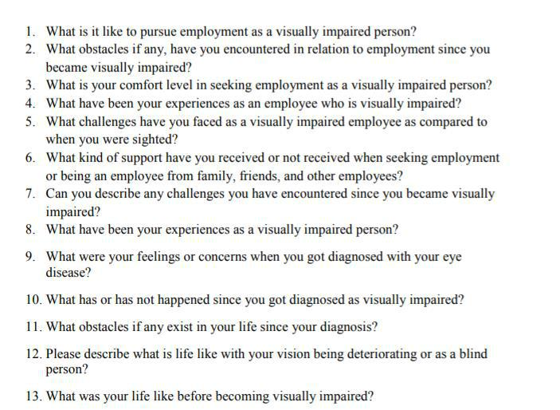

*Figure 38: Interview questions*



74 | P a g e

Appendix B - Evaluation form

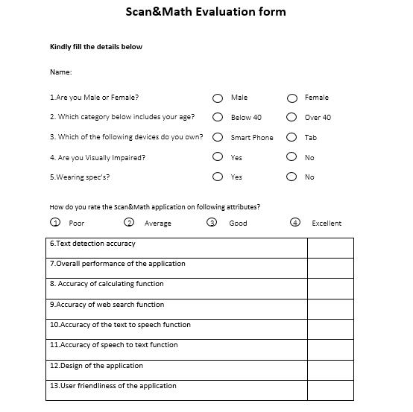

*Figure 39: Evaluation form part 1*



75 | P a g e

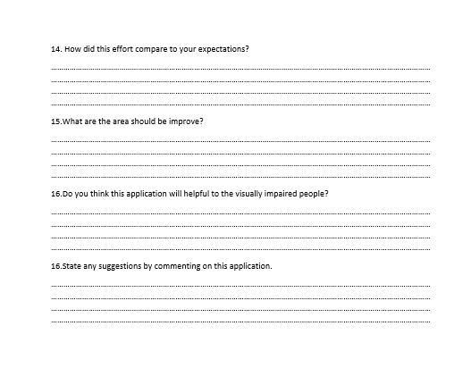

*Figure 40: Evaluation form part 2*



76 | P a g e

Appendix C - Poster

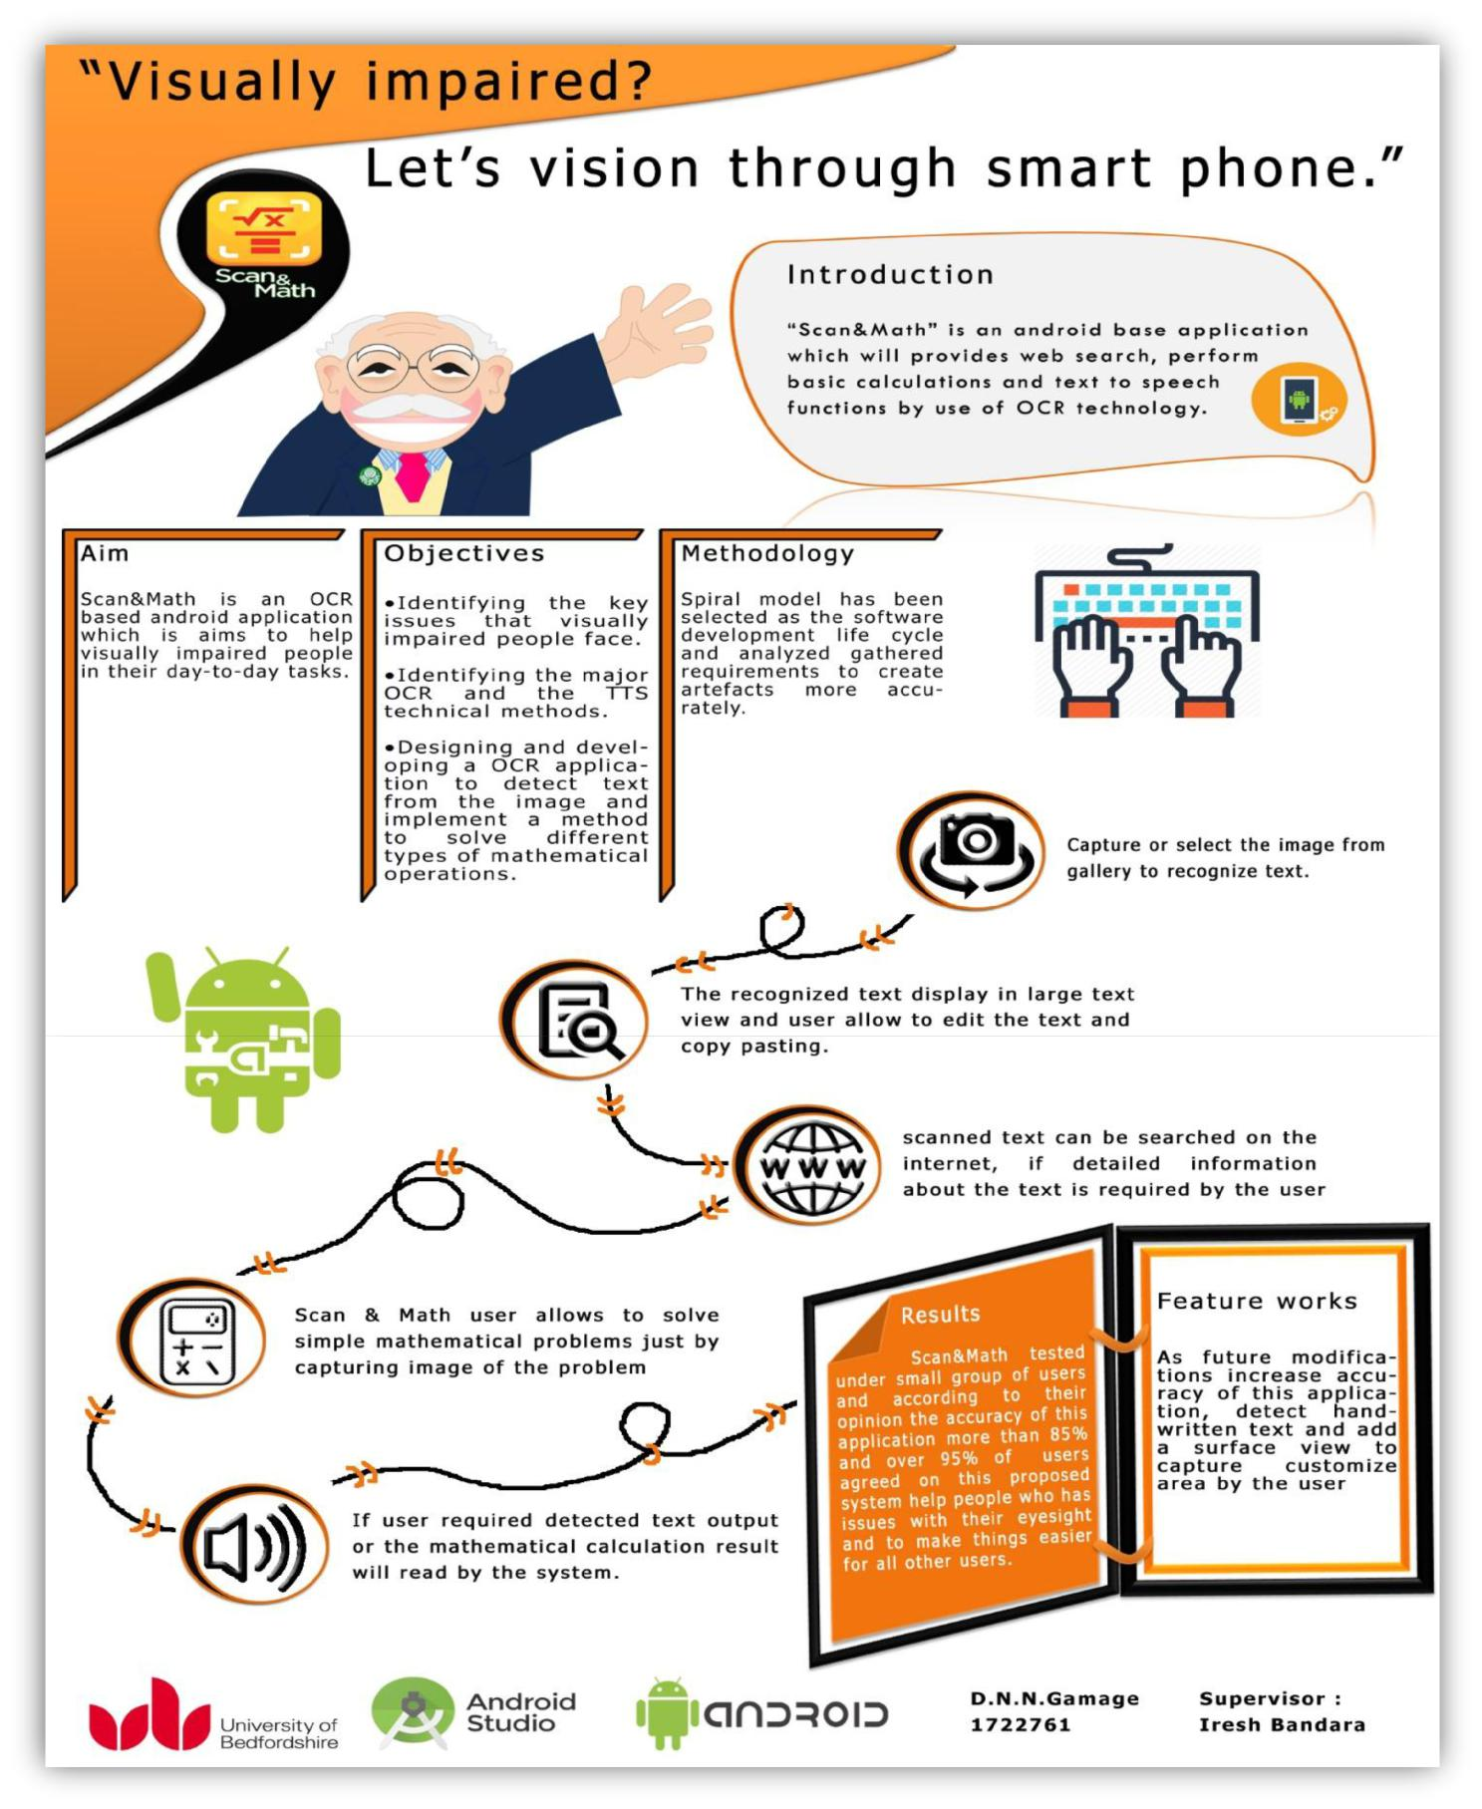

*Figure 41: Poster*



77 | P a g e